

A series of transition activities for year-11 students intending to study Sociology A-Level

Introduction

This document contains 6 separate activities, each of which should take around 2 hours. Together, they provide an insight into Sociology, and should contribute to the development of skills and understanding that will be useful for years 12 and 13.

Work through them, either on a computer or print it first and then do the activities in pen. You’re expected to do Activity 1 and 2. The remainder are non-compulsory, but it’s beneficial for you to at least engage with them.

At the end of this booklet is a compulsory task which will be handed in and assessed

Bring your print-outs and/or your notes to your first Sociology lessons in year-12

Recommended sources

To complete the activities, you may find some of these recommended sources useful:

www.sociology.uk.net (see ‘student activities’ for content that’s relevant to the textbook used in class)

www.sociology.org.uk/rload.htm (includes a load of class notes and PowerPoints on a range of Sociological topics)

www.s-cool.co.uk/a-level/sociology (a popular site, that might be worth checking out)

www.tutor2u.net/sociology/blog/videos (video slips and blog comments on a wide range of topics and news stories relevant to Sociology)

https://thesociologyguy.com/revision-notes/ (many colourful revision notes, but not on all topics)

www.youtube.com/watch?v=68eFC1_nIwA (good video on education)

www.thesociologyteacher.com/a-level-sociology (materials mostly aimed at Sociology teachers, but they cover a good a range of topics)

www.thesociologyteacher.com/education-sociology-revision (same as above, but specifically on education)

www.aqa.org.uk/subjects/sociology/as-and-a-level/sociology-7191-7192 (information on the course studied at Countesthorpe Academy, by the exam board we use to examine our students)

https://www.youtube.com/watch?v=OyFxxnLVAOk
(a YouTube video on the main Sociology perspectives)

www.bbc.co.uk/news (often has news stories relevant to Sociology)

www.theguardian.com/uk (another newspaper that often has stories and features relevant to Sociology)

www.independent.co.uk (another UK newspaper that often contains stories relevant to Sociology)

Activity 1: What is Sociology?

Activity 1.1: Using at least two different sources, write your own definition of what ‘Sociology’ is

What is Sociology?

Activity 1.2: Consider each of these statements about studying Sociology below, and comment on whether you think each of them are true or false (e.g. explain why you chose true or false, and why others might disagree with you).

Statement about studying Sociology | T or F | My thoughts on the statement, and why I chose true or false
1. Sociology is an easy subject

2. Sociology is mostly ‘common sense’
3. It’s assessed entirely by exams

4. The course is relevant to all careers
5. You’re expected to contribute your own ideas
6. You don’t have to write essays

7. Studying sociology makes you a nicer person
8. Some employers and universities don’t accept Sociology
9. Sociology is just a matter of opinion

10. You can succeed in sociology by simply learning your notes

Activity 1.3: People talk about the ‘society’ we live in, and how ‘society’ has changed. Some say that ‘society’ influences us, while others say individuals influence ‘society’. It’s argued that the UK is now a multicultural society. But what is ‘society’? Using several of the recommended sources from page 2, write down a definition of ‘society’.

What is a society?

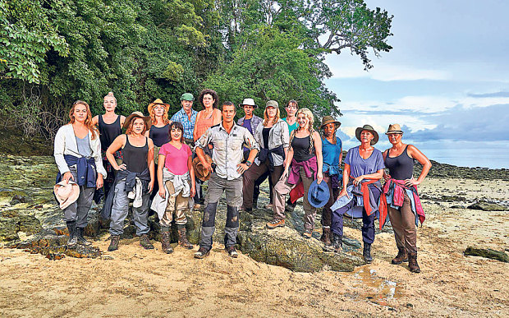
Activity 1.4: You’ve probably seen programmes in which people like Bear Grylls place people on deserted islands and then watches how they cope, or films in which planes crash land in an isolated mountain range or desert – and the people struggle to cope.
Now imagine you’re on an aeroplane and it does an emergency landing on an uninhabited island in the middle of the Pacific Ocean. There are no ‘relationships’, no ‘customs’ and no ‘systems’ on the island when you arrive. Have a conversation with people in your household or smartphone conversations with friends, and fill the following boxes with answers to the following question:

What does an island need for it to be considered ‘a society’?

Some form of hospital
Activity 1.5: Sociology is an academic discipline that looks at how people live, behave and work together in groups. It also looks at how societies work – and the roles (or ‘functions’) that their different parts play. Select a few of the boxes in activity 1.4, and explain the function they perform for individuals and for society (e.g. if you’re stuck, think about what would happen if they did NOT exist). The first one is done for you.

Features or parts of society | The function they serve for individuals and for society
Hospitals | Treat illness to cure people and prevent the patient deteriorating and suffering long-term consequences or death. In some cases, they also prevent the spread of the illness to others. Hospitals also provide people with jobs.

Activity 1.6: You no doubt understand that British society is different now to what it was 100 years ago. Sociologists are interested in what they call ‘social change’, which refers to: ‘changes in social attitudes, in social action, in social processes and in the structure of society’. Comment on each of these categories, such as what it might mean and/or an example. Speak to relatives who are older than you if necessary:

Form of ‘social change’ | Comment and/or example
Changes in social attitudes

Changes in social action

Changes on social processes

Changes in the structure of society

Activity 1.7: Sociology A-Level consists of four compulsory topics, which are: Sociology of Education; Sociological research methods; Sociological theory; Crime & Deviance. It also consists of two other topics, and at Countesthorpe Academy, these are: Families & Households and Global development. Speak to older members of your household, and write down some ways in which attitudes, social action and/or processes relating to education and crime have changed over recent decades.

Topic | Ways in which we’ve seen ‘social change’
Education

Crime

Activity 1.8: Now select any six of the following aspects of society and comment on some of the related changes we’ve seen in recent decades: marriage & divorce; religion; fashion; gender roles; having children; technology; leisure; sexuality; media; language; politics & voting; travel & transport; attitudes to mixed-ethnic relationships.

Aspect of society | Ways in which we’ve seen change
Activity 1.9: Sociology explores ‘social change’ and attempts to formulate explanations for it. Sociology tries to explain why such changes occur. Return to your work for 1.8, and use the table below to provide a possible explanation for why at least three of them have happened.

Example of social change | Possible explanation for such changes

Use this space for any further notes

Activity 2: Crime, pandemics and other social problems

Activity 2.1: Sociology is interested in ‘social problems’, which are aspects of society that are undesirable and have a negative impact on many people in society. If a teacher finds classroom behaviour stressful, then this is his/her ‘personal problem’. However, if a significant number of teachers decided (over several years) that student behaviour was so poor that they all left the profession, then this could become a ‘social problem’ – as a shortage of teachers would impact on many students and would be a problem for wider society. In the boxes below, add a few aspects of society that provide evidence that society is not perfect, and which might be described as ‘social problems’:

A shortage of physics teachers

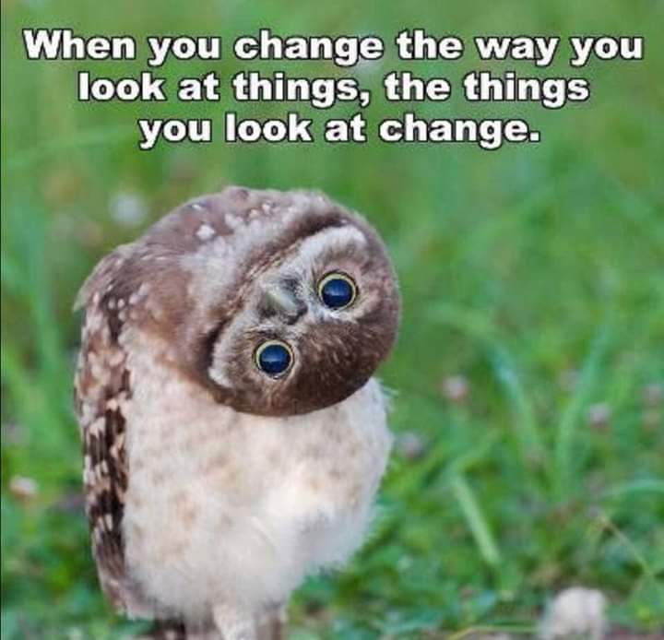
Activity 2.2: Sociology attempts to provide explanations for why things happen in society. They attempt to explain the existence of ‘social problems’, and challenge the ‘common-sense explanations’ which are often provided by the mainstream media. For example, a newspaper like The Sun might explain the UK’s high rate of teenage pregnancy by suggesting British girls don’t understand contraception; or that a teacher shortage is caused purely by poor student behaviour. Provide a ‘common-sense explanation’ for each of the following aspects of society:

Social problems | Common-sense explanations
Homelessness

White boys underperforming in exams
People claiming unemployment benefits

Young people taking drugs

Activity 2.3: Sociology investigates ‘social problems’ to try to explain them effectively. They conduct social research, using questionnaires, observational techniques, interviews, official government statistics and other methods to find a ‘valid’ explanation for social action, social attitudes and social processes – including those which are negative and are ‘social problems’. Now return to the issues above and provide some possible explanations that a sociologist might find by conducting a thorough sociological investigation using the methods mentioned above. Try to provide more than one explanation for each.

Social problems | Possible Sociological explanations
Homelessness

White boys underperforming in exams
People claiming unemployment benefits

Young people taking drugs

Activity 2.4: Consider the meme above, featuring an owl. With examples, explain what you understand by the meme, and how it relates to Sociology.

Analysis of a meme
Activity 2.5: The government uses ‘social policy’ to attempt to fix certain social problems. For example, one of the problems associated with drug abuse is addressed by providing a ‘needle exchange’, to discourage heroin users from sharing needles and spreading illnesses like HIV or hepatitis and from discarding dirty needles for children and others to pick up. Sociologists sometimes attempts to influence government ‘social policy’. For two of the social problems mentioned in either of the activities above, makes some suggestions for addressing them – to either fix the problem or minimise the negative impact they have on society.

Social problem | Possible suggestions for addressing the problem

Activity 2.5: There are several ‘social problems’ that are associated with the COVID-19 pandemic in the early 2020s. Infection rates were high, thousands died because of it and tests, vaccinations were expensive, and it left a legacy of poor mental health. As well as the implications for health, the pandemic also negatively affected wider society – both directly and indirectly. In the box below, describe your understanding of the statement that ‘events like a global pandemic can have both direct and indirect effects on people’s lives’. Provide some good examples. If you’re unsure, swop the pandemic for a problem like poverty or crime.

Direct and indirect effects of the pandemic
Activity 2.6: Think about the pandemic and the social problems it caused. These might relate to issues like: schools and exams, the closure of shops and services, people’s freedoms being restricted, criticisms of the government’s response, death of loved ones and many more. Using the ideas of your parents and/or other adults, add some notes to the table below:

Ways the pandemic impacted on society – directly or indirectly | Sociological comments (e.g. explain the consequences, explain the behaviour) | Social policy ideas to address the problems

Activity 2.7: In Sociology exams, students are expected to be evaluative, and to present arguments both for and against, or both strengths and weaknesses. Regarding the pandemic, there were positive impacts on pollution and wildlife, many people evaluated their life, and some were forced to become resilient and independent – therefore learning new skills. In the boxes below, describe some of the potential positive consequences of the pandemic.

Positive aspects of the COVID-19 pandemic

Use this space for any further notes

Activity 3: Crime & deviance

Activity 3.1: Sociology is interested in a range of issues relating to crime, including seeking explanations for why some people commit crime and why most people conform to the law. It also looks at the different rates of crime between different social groups – such as men and women and different age groups. Before we go any further, use the ‘sociological imagination’ you’re beginning to develop (rather than ‘common sense’) to make some suggestions why there might be differences in offending rates between the following pairs of social groups:

Social groups | Why offending rates differ
People between 16 and 21, and people over 50

Males in their 20s and females in their 20s

Black Caribbean people and people of Indian origin

People who live in rural villages and people who live in urban areas

Wealthy people and those on low incomes

Activity 3.2: Part of studying crime involves analysing official crime statistics that have been compiled by the police, the courts and other organisations within the criminal justice system. This analysis involves looking at differences between social groups and between locations (e.g. different towns), but also looking at changes over time. Choose one topic from the following list, and complete the task that’s explained beneath it: drink-driving; football hooliganism; knife crime; drug dealing; sexual assault; environmental crime; internet fraud; vehicle theft; human trafficking; homicide; racially-motivated offences; burglary; something else.

Use your internet-research skills to seek some government or police statistics on your chosen topic. You may wish to use resources such as: Office for National Statistics; the British Crime Survey, the Home Office or Police.org.uk.
Once you’ve found a table or graph, extract some statistical data from it (e.g. a handful of years, a few locations) and create a simple graph that presents the data you’ve selected. You can do this by using Excel to carefully plot some data, and then create a bar chart – or you could go ‘old school’ and draw it by hand. Insert your graph in the space below – or provide written findings instead:

Activity 3.3: Analyse your graph in the box below, by explaining what the data shows. For example, what changes happened over time? when did the crime peak? where are there some comparisons and some contrasts? what conclusions can you make about your chosen crime topic?

Analysis of crime data
Activity 3.4: Sociologists make use of official crime statistics, but they are cautious because they are ‘socially constructed’. This means, they are not naturally correct but are the product of decision-making by people involved in the criminal justice process – such as offenders, victims, witnesses, police officers and members of juries. Therefore, lots of crimes are undetected (e.g. speeding), many are not reported to the police (e.g. a burglary where nothing was taken), and some are reported to the police but are not actually recorded by them or followed-up. Complete the following table with your own thoughts and those of people you live with. If possible, conduct some text or phone interviews with crime victims and any police officers you know

Some reasons why crime victims and witnesses don’t report crimes to the police | Some reasons why police officers might not record or follow-up crimes reported to them

Activity 3.5: ‘Crime’ refers to behaviours which are against the law (at the time at which they are committed and in the place in which they’re committed), so it includes killing someone on purpose, stealing from shops, smoking cigarettes in pubs and using a mobile phone whilst driving. However, ‘deviance’ is not the same as crime. ‘Deviance’ refers to behaviour which is against ‘social norms’ (i.e. is socially inappropriate and against what is expected of people) and is widely frowned upon. Therefore murder and the wearing of peculiar clothing to a funeral are both ‘deviant’, despite them not both being criminal. This is mind, study the following table and tick whether each behaviour is criminal, deviant, neither or both. Add your own ideas to the blank rows:

Social behaviour | Crime | Deviance | Neither
Kissing your best friend’s girlfriend
Smoking cannabis at a music festival
Playing Candy Crush at a funeral
A homosexual relationship
Being over-changed and keeping the money
Hiding money under your bed to avoid tax
Burping loudly in a restaurant
A male teacher who’s a drag queen
Being married to two women
Parking on yellow lines to pop into a shop
An adult getting drunk at home
A man shouting abuse in the street
Murdering a neighbour over loud music
Being rude to a teacher who’s trying to help
Having sex with someone who’s nearly 16
Driving on the left side of the road in the UK
Taking printer paper home from work
Driving 100mph on a motorway

Activity 3.6: Now that you’ve given some consideration to crime and deviance, comment on whether or not you agree with each of the 10 statements below:

- All crime should be punished

- Poverty causes crime

- We all commit crime, but some are more likely to get caught

- Drug-taking shouldn’t be a crime, because the only victims are users themselves

- Males and females commit different crimes and different amounts of crime

- Violence on TV and in computer games make people commit crime

- Prisoners should serve their full sentence, even if they’ve shown good behaviour and rehabilitation

- What is classed as ‘deviant’ varies between different social groups and between different places

- It’s wrong for the police to stop people based on their appearance

- Some people are more at risk of being a victim of crime than others

Use this space for any further notes

Activity 4: Education

Activity 4.1: In year 12, we study the Sociology of Education. This topic includes studying the role that education plays for society, the government policies which have shaped the education system, gender differences in subject choice and a range of concepts like ‘pupil subcultures’, ‘pupil identities’ and ‘the globalisation of education’. It also involves studying ‘educational inequalities’ and explaining why students from certain social groups experience greater achievement that others. Using your developing ‘sociological imagination’, provide some possible explanations for differences in grades and skills between the following groups. Try to consider issues such as: finances, parents, discrimination, family culture, family types, teacher attitudes, ‘social norms’, what’s taught in schools and other issues.

Social groups | One possible explanation | Another possible explanation
Girls generally do better than boys

Students from ‘middle-class’ families tend to do better than ‘working-class’ students

Some ethnic groups (e.g. Indian) generally do better than others (e.g. black Caribbean)

Activity 4.2: Within Sociology there are several ‘perspectives’, which look at society and its features (e.g. education and crime) in different ways. These include perspectives like Functionalism, Marxism, Feminism, the New Right, Symbolic Interactionism and Postmodernism. With regards to education, each of these have different views on its purpose. From discussions with people you live with (or can communicate with in other ways), respond to the following questions:

- What do you think is the purpose (or purposes) of education?

- Why does society want you to be educated?

- What role or ‘function’ does a school serve for individuals and for wider society?

Activity 4.3: An American ‘Functionalist’ called Talcott Parsons argued that for society to ‘function’, certain things need to exist or need to happen. Thinking back to the aeroplane landing on the uninhabited island in task 1.4, we could use the concept of ‘functional pre-requisites’ to explain that certain things are needed (e.g. healthcare, waste disposal, shelter, rules) for the society to work - or ‘function’. Parsons argued that for a society to work, it needed to:

- adapt to situations and surroundings (e.g. make use of resources on an island)

- integrate people, to ensure people get along and work together (e.g. avoid conflict on the island)

- allocate roles to people (e.g. collecting firewood, caring for children, treating illness)

- enable people to attain goals (e.g. to feed their children, to have a role they enjoy)

- ensure systems, routines and ‘patterns’ can be maintained and can be sustainable over time (e.g. ration the food, raise the next generation).
Considering each of Parsons’ five ‘functional pre-requisites’, use the table below to explain how education serves these functions for society and for individuals?

Functional pre-requisite | How education serves this function for individuals and for society
Adaptation
Integration
Role allocation
Goal attainment
Pattern maintenance

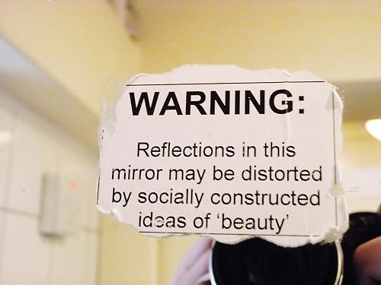
Activity 4.4: In an earlier activity about crime statistics, you considered the concept of ‘social construction’. It refers to how things are not a natural occurrence, but are created through social processes (e.g. interacting with others and making decisions). For example, the fact that Saturday and Sunday are ‘the weekend’ is not natural but was decided. What’s right and what’s illegal was also constructed and so were gender roles and how to elect a government. This is why there are different expectations of men and women in Muslim communities compared to others, and why Donald Trump was elected President despite his rival Hilary Clinton receiving more votes. This is mind, use the box below to comment on the picture showing a sticker that someone stuck on a public toilet mirror:

Social construction of ‘beauty’
Activity 4.5: The education system is also a ‘social construction’. It is different in one country to the next, and changes over time. It’s not ‘natural’ for schools to consist of classes of 28 children all of the same age being taught a subject for 60 minutes by one teacher and then to move to another room to be taught something else by another teacher. Watch these two video clips, and then respond to the questions below. If you can’t access these clips, conduct research by using the terms in brackets.

www.youtube.com/watch?v=r1Y0cuufVGI (New Zealand ‘no rules’ school)

www.youtube.com/watch?v=yt9GtLCaNpU (Summerhill School in England)

- What are your thoughts on the New Zealand school, and its Head Teacher’s attitude of ‘the only rule is that they don’t kill each other’?

- In what ways does Summerhill School differ from your own experience of education?

- What are your thoughts on the way Summerhill is run? Do you agree with its systems? Would you like to send your own children there?

Activity 4.6: In recent years, the UK government has introduced ‘Free schools’, which can be set up by faith groups, by companies, by groups of parents, or by anyone who wants to offer an alternative ‘curriculum’ (a term which refers to what is taught in schools). Conduct some brief research into ‘free schools in the UK’ and ‘Charter schools in the USA’ (e.g. what are they, how are they run, how common are they, where are some local examples?). Jot your notes in the box below:

Free schools and charter schools

Activity 4.7: You now know that schools do not have to run a particular way. Now consider what your ideal ‘school’ would look like. From discussions with people you’re able to communicate with, use the box below to present your own ‘free school’. You might wish to consider: What it would provide; what ‘subjects’ it would teach; the ‘rules’ that would be implemented; the school’s ‘ethos and the views it would hold important; what it would intend to pass on to the students; and how the days would be structured.

My ideal Free School
Use this space for any further notes

Activity 5: Families and Households

Activity 5.1: In Year-12 at Countesthorpe, we study Families & Households. Whilst these two terms overlap, they are not the same. A ‘family’ refers to two or more people who are related by either blood, marriage or legal adoption. They don’t have to live together or share any household tasks, but so long as they are related, they are a ‘family’ whether they like it or not. A ‘household’ is a broader term and simply refers to who lives in a particular house, flat or other dwelling and to some extent shares resources and responsibilities. Therefore, a block of flats contains several ‘households’, some of which may well be families too. Study the table below and decide whether each group of people are a family, a household or both:

People | Family? | Household?
Married man and woman and their children
Single man living alone
Married couple whose kids have left home
Unmarried young couple without kids
Lesbian couple with child related to one of them
Unmarried couple with their grown-up children
Grandparents with their granddaughter
3 friends living in the same house
Unmarried couple with kids from previous relationships
Marred man and woman with their dogs
Divorced mother and her grown-up son
Woman with 3 children by 3 different fathers
Widowed woman living alone
Mother and daughter, with grandma living with them
Grandparents, parents and grandkids living together
Woman with her adopted daughter

Activity 5.2: As the table above shows, there is a variety of household types, and indeed family types too. A ‘nuclear family’ refers to a married, opposite-sex couple with their child or children who are biologically related to both of them and living home dependent upon them to some extent. Thinking of people you know and in the media. Jot down some families that are definitely ‘nuclear’:

Nuclear families
Activity 5.3: It’s argued by many Sociologists that the nuclear family is no longer the norm, and have been replaced by ‘family diversity’, which refers to a variety of different family types, some of which can be found in table for Activity 5.1. Sociologists from the ‘Postmodernist’ perspective such as Diana Gittins and Judith Stacey argue that family diversity has been caused by an increase in choice and free will. They say we can choose who to live our lives with and aren’t stuck in one family type – or forced by society to live a certain way. In the space below, explain whether you agree with this view, or and whether there are any other reasons why many people have moved away from the traditional nuclear family:

Causes of family diversity

Activity 5.4: Conduct some IT research into the extent of family diversity. Attempt to find out the % of households which are nuclear, lone-parent families, step (blended) families, same-sex families, for example. Add your findings below:

Activity 5.5: Sociologists from the ‘New Right’ perspective are concerned about family diversity, and argue that the nuclear family is far better than any alternative. A bit like Functionalists, they argue that the nuclear family is far better at meeting the needs of family members and wider society. In the space below, and with reference to issues like childcare, raising and disciplining children, domestic tasks, incomes, stress and emotional issues, companionship, conflict and schooling; what arguments could you make to suggest that nuclear families are the most effective?
Nuclear families are an effective family type because ….

Activity 5.6: However, Sociologists from the Marxist, Feminist and Postmodernist perspectives are critical of the New Right’s view, as they don’t believe the nuclear family is as perfect as is suggested. What arguments could you present that the nuclear family is not always ideal, and/or that sometimes alternatives are better?

Problems with nuclear families & strengths of alternatives
Activity 5.7: Study each of the statements below, which present the views of different Sociological perspectives on the issue of family diversity. Highlight or circle which one (or ones) you most agree with, then explain why you feel this way:

- Several family types in one lifetime is irresponsible, immoral and encourages families to be dependent on welfare benefits (The New Right)

- We all have choice about how to live our lives, and this choice leads to family diversity. This should be celebrated (Postmodernism)

- Family diversity isn’t ideal, as nuclear family are best in principle. However, if it works for individuals and for society, then so be it. (Functionalism)

- We all have ‘free will’ about who to live with, and family ‘means’ different things to different people (Symbolic Interactionism)

- Choice and acceptance of alternatives to the nuclear family is great, but the powerlessness of many women (e.g. financial-dependence on men) restricts women’s choices (Feminism)

- Choice about who to live with isn’t available for all. The lower classes and/or those with limited finances are often forced to stay in unhappy and non-ideal living arrangements (Marxism)

Explaining my own view on family diversity
Use this space for any further notes

Activity 6: Global issues

Activity 6.1: You know what’s meant by ‘social construction’, and like aspects of education and crime, family is also ‘social constructed’. What is considered the ‘right’ or ‘ideal’ family type changes over time and varies between societies, because there is no ‘natural’ family type. Conduct some IT research into the family arrangements, parenting and childhoods in a few of the cultures listed below, and note your findings in the table beneath it. Note: you’ll probably find some of the information to be truly shocking! But remember that what is ‘normal’ for us (e.g. marriage between just two people, waiting until at least 16 to marry, etc) is probably unusual for people of other cultures.
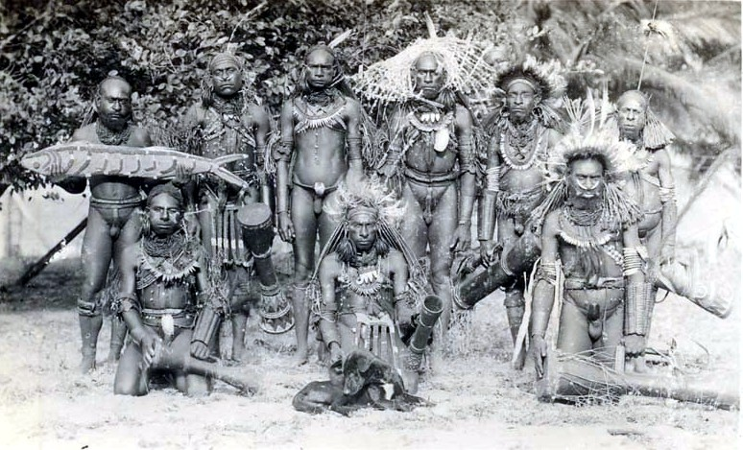
- The Ik people of Uganda
- The Nayar people of Northern India
- The Himba tribe of Africa
- The Trobriand Islanders
- the Toda people
- Kibbutz in Israel
- The Lakker people of Burma
- The Marind-anim
- The Nuer people of the Nile Basin
- Banaro of New Guinea

Name of the culture or society | Some key features of family life, parenting or childhoods
Activity 6.2: In the Global Development topic in year-13 (and indeed in other topics), we study the concept of ‘globalisation’. The term refers to increasing relationships between countries (e.g. with regards to business, politics and social relationships), but also increasing influence (and even dependence) between countries. Considering issues like culture, business, communication, the economy, education, technology, travel, politics and other areas; fill the boxes below with evidence that we’re becoming more ‘globalised’?

Covid-19 affected several nations because of international travel and tourism
Some cars are made in China, made from parts from all over the world

Activity 6.3: As well as the Global Development topic, the concept of globalisation pops up in families & deviance, education and crime & deviance. Conduct some IT research into the relationship between globalisation and these areas, and use the boxes below to comment on the impact of globalisation:

 | Some positive effects of  globalisation | Some negative effects of  globalisation
The education system
Crime rates
Family types
Use this space for any further notes

Well done for completing these activities. Don’t worry if you’re unsure of your responses to some of them. The main point is that you’ve been introduced to some of the topics Sociology studies. We can discuss some of this when your A-Levels start, but if you do have any pressing questions, contact the Sociology teacher via drushin@clcc.college
Letter for parents

June 2026
Dear Parent/Guardian

To support their studies, students will be provided with a laptop or other electrical device. Throughout the course, certain scan-ins from textbooks will also be emailed to them, to use in class and/or at home.

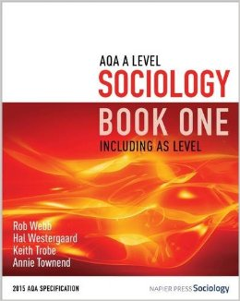
However, it would be immensely helpful for students to have their own copy of a particular textbook, at home - which they can highlight and annotate where necessary. As well as providing subject knowledge which students will be examined on, the textbook below is particularly good for boosting grades because of its inclusion of example questions and advice on exam technique. Parts of this textbook will be used in class and at home to support your child’s exam preparation for the Sociology exams in June of 2028. The book will be useful in year 13 too.

The title is ‘AQA A-Level Sociology book one – including AS Level’, and it’s written by Webb, Westergaard, Trobe and Townsend (2015). It’s published by ‘Napier Press Sociology’. The cover is orange and white and looks like the image to the right.

You may be lucky enough to know someone who has this book they no longer need (so long as it’s the right edition) or you may find a used copy online.

If you face problems with regards to the cost of this textbook or indeed any other materials needed for the course, please speak with the 16+ office, as in some cases financial support is available. This of course would be dealt with discreetly.

If you need to contact me with regards to this or any other issue, please do so via drushin@clcc.college or 0116 2771555

Yours Sincerely

D.J. Rushin
Sociology
Countesthorpe Academy

These final two pages feature a COMPULSORY task that will be submitted and assessed
Activity 7: Compulsory summer assessment

Whilst you should pick and choose which of the previous activities to do, there is one task you MUST have completed before your first Sociology lesson in September:

Study the graph on ethnicity and households (below), and carefully follow the instructions on the next page. This is your opportunity to make a great first impression and show how committed you are.

Let’s see if you can follow some simple instructions!!!!

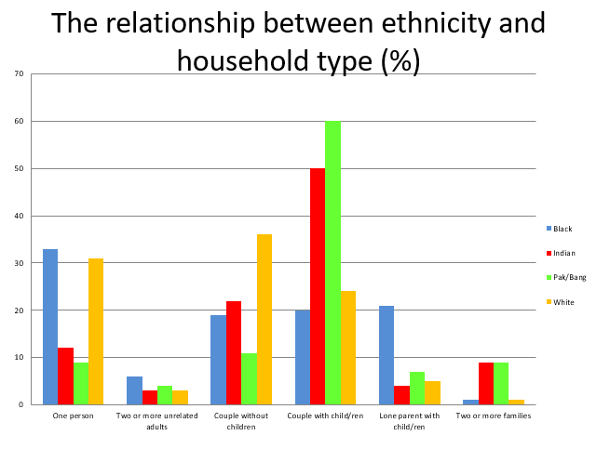

Instructions

To enable us to assess your literacy, numeracy and analytical skills at the start of the course; please complete the following task. This should be completed on a separate piece of paper - and then be handed in during your first Sociology lesson.

Study the graph on the previous page. Carefully analyse it, perhaps discussing it with someone else before writing (note that, because it’s about percentages, each ethnic group adds up to 100)

Note that not all ethnic groups are represented on the graph (e.g. Chinese people are not included), and ‘Pak/Bang’ refers to Pakistani/Bangladeshi.

Note that the household’s ethnicity refers to the ethnicity of the household’s adult male – or the adult female where no man is present.

Your report should be no less than 400 words, and no more than 500.

Your report should:

- refer to any interesting comparisons and contrasts,

- attempt to explain such differences and similarities,

- discuss any potential problems with the graph’s likely accuracy,

- identify any other criticisms of the graph,

- be word-processed,

- be presented appropriately (e.g. paragraphs, title, proof-read),

- be brought to the first lesson – without fail!

