**

**__________________**

**Approaching A-Level**

**English Literature**

**Induction Booklet**

**__________________**

**If you are studying English Literature A-Level at Countesthorpe Academy, you will need to purchase the following texts before the start of year 12:**

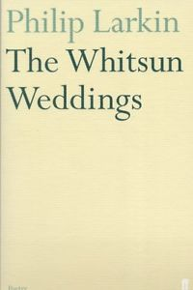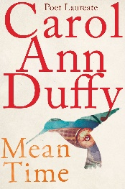

Carol Ann Duffy Philip Larkin

***Mean Time*** ***The Whitsun Weddings***

(Picador) (Faber)

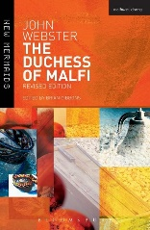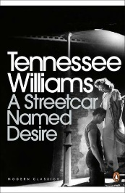Tennessee Williams John Webster

***A Streetcar Named Desire*** ***The Duchess of Malfi***

(Penguin Modern Classics) (Methuen)

________________________________________________________________

**You will also study these texts later in year 12 and in year 13. You do not necessarily need to purchase these straight away:**

[](https://www.google.com/url?sa=i&url=https://www.amazon.co.uk/Tenth-December-George-Saunders/dp/1408894815&psig=AOvVaw0zg81ulOlAibZK9uzNs_uK&ust=1588257162864000&source=images&cd=vfe&ved=0CAIQjRxqFwoTCKiWu4PtjekCFQAAAAAdAAAAABAD)Chuck Palahniuk George Saunders

***Fight Club***  ***Tenth of December***

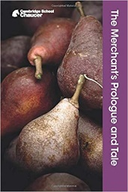

Geoffrey Chaucer

***The Merchant’s Prologue and Tale*** (Cambridge)

[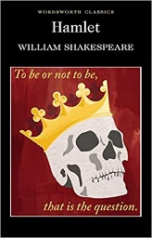](https://www.google.com/url?sa=i&url=https://www.amazon.co.uk/Hamlet-William-Shakespeare/dp/1853260096&psig=AOvVaw0b16klMfm9CXqT2-8mEd0M&ust=1588257263574000&source=images&cd=vfe&ved=0CAIQjRxqFwoTCPipkqztjekCFQAAAAAdAAAAABAK)

William Shakespeare

***Hamlet***

**Component 1: Poetry**

*Mean Time* (1993) and *The* *Whitsun Weddings* (1964)

**Component 1B: Comparative Poetry (open-book) I hour**

**Paired texts: *Mean Time by Carol Ann Duffy and The Whitsun Weddings by Philip Larkin***

In this unit of the induction pack, you will be starting your study of these two fantastic poetry anthologies. You will look at individual poems and compare similarities and differences between the poets’ work.

**You will need to demonstrate your ability to:**

* analyse how meanings are shaped in poetry anthologies
* show understanding of the cultural and contextual influences on readers and writers
* use accurately a range of literary concepts and terminology, including knowledge of the principles and conventions of poetry.
* reflect on different interpretations of literary texts, including, where relevant, critical interpretation; debate alternative ideas about a text and consider multiple readings
* identify and consider how attitudes and values are expressed in texts
* organise responses in a clear and effective academic style and register with coherent written expression
* explore productive connections and contrasts between poems from different periods
* use accurately quotations and references to texts and sources.

As you read the poems, you need to be thinking about:

* the key themes and ideas being explored;
* characterisation;
* context;
* language, imagery and symbolism;
* poetic structure and devices;
* how other readers (critics, directors or audiences) might interpret the poem.

**POETRY TASK 1:**

**Get to grips with a poem.**

In this poem, Duffy explores the impact of an early experience of love.

**‘First Love’ by Carol Ann Duffy**

**Approaching a poem:**

1. Read the title & poem and think about it. First impressions? What mood does it create?

2. Annotate the poem for ideas and the methods the poet has used to create those ideas.

3. Consider structure/form – e.g. free verse, dramatic monologue, sonnet. Why is this important to understanding the poem?

4. Research the poem. Is there else anything important in terms of context which helps with interpreting this poem?

Waking, with a dream of first love forming real words,  
as close to my lips as lipstick, I speak your name,  
after a silence of years, into the pillow, and the power  
of your name brings me here to the window, naked,  
to say it again to a garden shaking with light.

This was a child's love, and yet I clench my eyes  
till the pictures return, unfocused at first, then  
almost clear, an old film played at a slow speed.  
All day I will glimpse it, in windows of changing sky,  
in mirrors, my lover's eyes, wherever you are.

And later a star, long dead, here, seems precisely  
the size of a tear. Tonight, a love-letter out of a dream  
stammers itself in my heart. Such faithfulness.  
You smile in my head on the last evening. Unseen  
flowers suddenly pierce and sweeten the air.

**POETRY TASK 2:**

**Comparing to other poems/poets**

Now have a look at this poem by Philip Larkin. This, too, is about an early experience of ‘love’, but Larkin describes a more cynical, detached observation.

**‘Wild Oats’ by Philip Larkin**

**Approaching a poem:**

1. Read the title & poem and think about it. First impressions? What mood does it create?

2. Annotate the poem for ideas and the methods the poet has used to create those ideas.

3. Consider structure/form – e.g. free verse, dramatic monologue, sonnet. Why is this important to understanding the poem?

4. Research the poem. Is there else anything important in terms of context which helps with interpreting this poem?

5. What connections can you make between the two poems you have looked at? Consider structure, language, themes & ideas.

About twenty years ago

Two girls came in where I worked—

A bosomy English rose

And her friend in specs I could talk to.

Faces in those days sparked

The whole shooting-match off, and I doubt

If ever one had like hers:

But it was the friend I took out,

And in seven years after that

Wrote over four hundred letters,

Gave a ten-guinea ring

I got back in the end, and met

At numerous cathedral cities

Unknown to the clergy. I believe

I met beautiful twice. She was trying

Both times (so I thought) not to laugh.

Parting, after about five

Rehearsals, was an agreement

That I was too selfish, withdrawn,

And easily bored to love.

Well, useful to get that learnt.

In my wallet are still two snaps

Of bosomy rose with fur gloves on.

Unlucky charms, perhaps.

**Component 2: Drama**

*A Streetcar Named Desire* by Tennessee Williams (1949)

**Component 2B: Comparative Drama (closed-book) I hour**

**Paired texts: *A Streetcar Named Desire* by Tennessee Williams and *The Duchess of Malfi* by John Webster**

In this unit of the induction pack, you will be starting your study of a brilliant twentieth century American play, *A Streetcar Named Desire*. Eventually, this play will be paired with the Jacobean revenge tragedy, *The Duchess of Malfi.*

**Learners will need to demonstrate their ability to:**

* analyse how meanings are shaped in drama texts
* show understanding of the cultural and contextual influences on readers and writers
* use accurately a range of literary concepts and terminology, including knowledge of the principles and conventions of drama and dramatic verse
* reflect on different interpretations of literary texts, including, where relevant, critical interpretation; debate alternative ideas about a text and consider multiple readings
* identify and consider how attitudes and values are expressed in texts
* organise responses in a clear and effective academic style and register with coherent written expression
* explore productive connections and contrasts between plays from different periods
* use accurately quotations and references to texts and sources.

As you read the play, you need to be thinking about:

* the key themes and ideas being explored;
* characterisation;
* context;
* language, imagery and symbolism;
* dramatic structure and devices;
* how other readers (critics, directors or audiences) might interpret the play.

**DRAMA TASK 1:**

**Stage Directions**

The exterior of a two-story corner building on a street in New Orleans which is named Elysian Fields and runs between the L & N tracks and the river. The section is poor but, unlike corresponding sections in other American cities, it has a raffish charm. The houses are mostly white frame, weathered grey, with rickety outside stairs and galleries and quaintly ornamented gables. This building contains two flats, upstairs and down. Faded white stairs ascend to the entrances of both.

It is first dark of an evening early in May. The sky that shows around the dim white building is a peculiarly tender blue, almost a turquoise, which invests the scene with a kind of lyricism and gracefully attenuates the atmosphere of decay. You can almost feel the warm breath of the brown river beyond the river warehouses with their faint redolences of bananas and coffee. A corresponding air is evoked by the music of Negro entertainers at a bar-room around the corner. In this part of New Orleans, you are practically always just around the corner, or a few doors down the street, from a tinny piano being played with the infatuated fluency of brown fingers. This "Blue Piano" expresses the spirit of the life which goes on here.

Two women, one white and one coloured, are taking the air on the steps of the building. The white woman is Eunice, who occupies the upstairs flat; the coloured woman a neighbour, for New Orleans is a cosmopolitan city where there is a relatively warm and easy intermingling of races in the old part of town.

1. Research the definition of the vocabulary highlighted.
2. Analyse the opening stage directions. Consider the atmosphere Williams creates and what we can infer about the setting from these details. Make at least five points, including quotation for each.



Can you analyse language use within each point –using terminology if possible? Example:

**Williams’ use of the adjective ‘infatuated’ to describe the fingers of the piano players suggests the depth of importance music has in New Orleans and the devotion to it that musicians feel. It also gives a slightly manic quality to the description, suggesting an atmosphere of creativity but also, perhaps, obsession.**

**DRAMA TASK 2:**

**Context Research**

**Tennessee Williams**, original name **Thomas Lanier Williams**, (born March 26, 1911, Columbus, Mississippi, U.S.—died Feb. 25, 1983, New York City): American dramatist whose plays reveal a world of human frustration in which sex and violence underlie an atmosphere of romantic gentility.

More than with most authors, Tennessee Williams' personal life and experiences have been the direct subject matter for his dramas. He uses his experiences so as to universalize them through the means of the stage.

**TASK**: Produce a context sheet about the life of Tennessee Williams and how his experiences, attitudes and environment influenced his plays. Look especially at his sister’s experience of mental illness.

***Important:*** *Please do not simply cut and paste chunks from websites. Organise your research into sections and/or bullet points.*

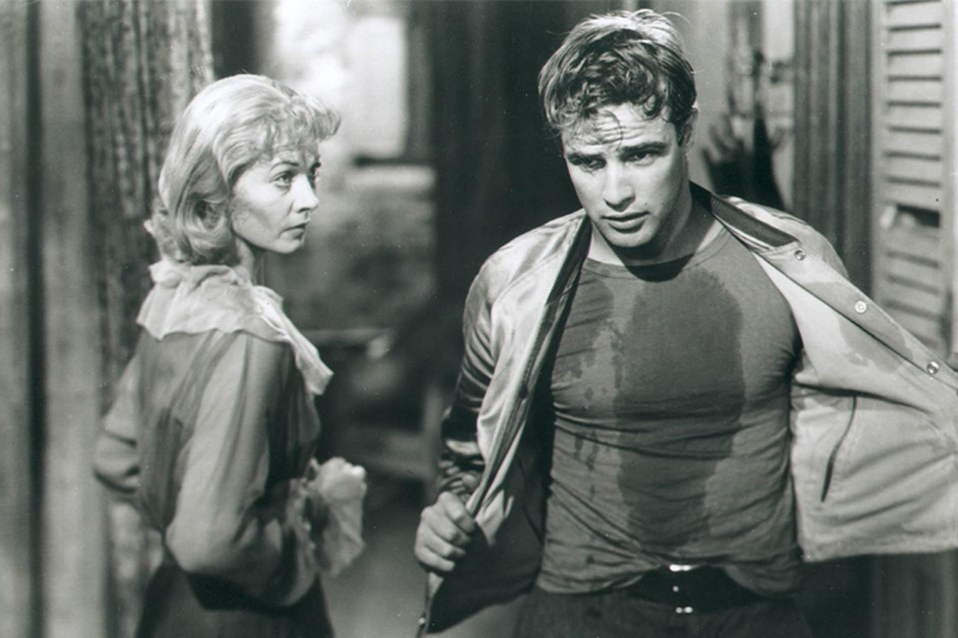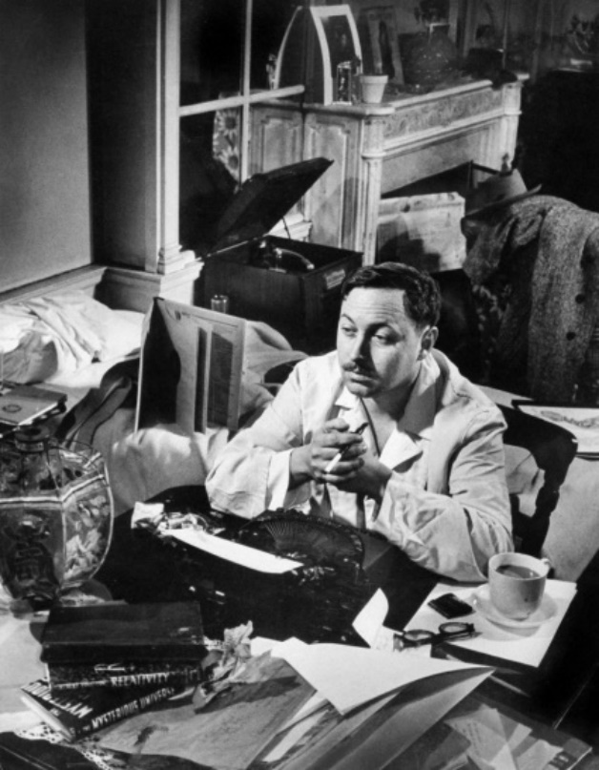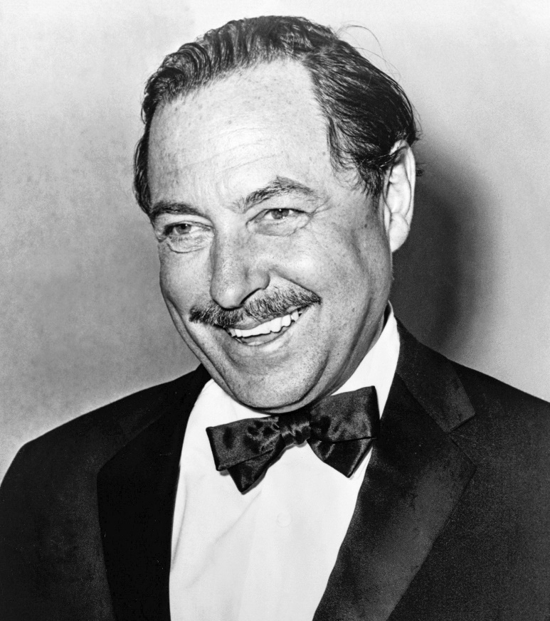

**That’s all for now – just a taster of the exciting things we have install for you during your English literature A-Level studies.**

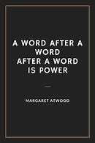**Just keep reading…**

********