**Transition Pack for A Level Chemistry**

Adapted by C Francis June 2025

Countesthorpe Academy



**Get ready for A-level!**

This resource is strictly for the use of member schools for as long as they remain members of The PiXL Club. It may not be copied, sold nor transferred to a third party or used by the school after membership ceases. Until such time it may be freely used within the member school.

All opinions and contributions are those of the authors. The contents of this resource are not connected with nor endorsed by any other company, organisation or institution.

[www.pixl.org.uk](http://www.pixl.org.uk) The PiXL Club Ltd, Company number 07321607

**A guide to help you get ready for A-level Chemistry, including everything from topic guides to interesting reads and online learning courses.**

Please note: these resources are non-board specific. Please direct your students to the specifics of where this knowledge and skills most apply.

**Commissioned by The PiXL Club Ltd. February 2016**

© Copyright The PiXL Club Ltd, 2016

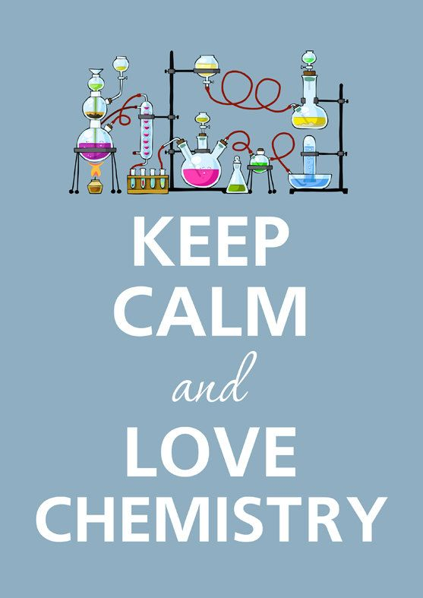

So you have chosen to study

A Level Chemistry?

This pack contains a programme of activities and resources to prepare you to start an A level in Chemistry in September. It is designed for you to complete throughout the remainder of the summer term and through the summer holidays to help you prepare for your course in September.

Deadline 8th September 2025.

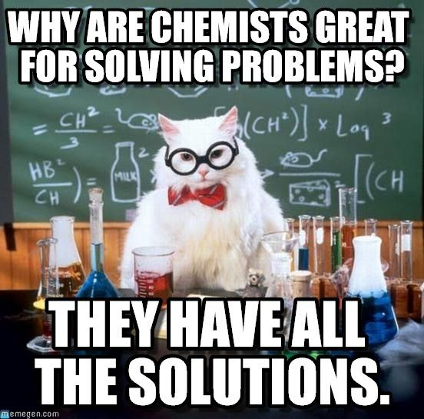**So what’s it like to study A level Chemistry at Countesthorpe Academy?**

Your teachers:

* Dr Francis (Lead Teacher for Chemistry) cfrancis@clcc.college
* Mrs Mifflin (Teacher of Chemistry) hmifflin@clcc.college

Your course:

* Following OCR A (from 2015) exam board
* All students are expected to complete the full A level course, we do not sit AS level exams.

To find out more about the course or view the specification use this link:

<https://www.ocr.org.uk/qualifications/as-and-a-level/chemistry-a-h032-h432-from-2015/specification-at-a-glance/>

The course content is split into six teaching modules:

* Module 1 – Development of practical skills in chemistry- this is taught throughout the course, not as an individual unit and involves completing a series of assessed practicals during the course alongside other practicals used for skill development and understanding concepts.
* Module 2 – Foundations in chemistry- This is a bridging unit between GCSE and AS and makes sure you understand the key concepts that underpin chemistry such as formulae and equations, moles, concentrations, oxidation and reduction, titration, electronic structure, bonding and shapes of molecules.
* Module 3 – Periodic table and energy – This looks in detail at trends in the periodic table, introduces you to the idea of ionisation energy, looks at understanding in more detail and being able to calculate energy changes in reactions, further ideas into rates of reaction and equilibrium.
* Module 4 – Core organic chemistry- Beginning with familiar ideas about alkanes and alkenes from GCSE we build on knowledge of naming organic compounds, introducing branching, isomerism and new functional groups such as haloalkanes, aldehydes and ketones. We also develop ideas about reaction mechanisms and synthesis and analysis of organic compounds.
* Module 5 – Physical chemistry and transition elements- taught in year 13 develops ideas from AS and GCSE on Equilibria, rates of reaction, Redox, enthalpy and entropy, transition metals and pH, preparing students for further study at university.
* Module 6 – Organic chemistry and analysis- Taught in year 13 this builds on ideas learned in AS and GCSE about organic compounds, learning about aromatic ring structures as well as further functional groups and more complex mechanism, isomers and synthesis of new compounds. We also put together a variety of analytical techniques to identify unknown organic compounds.



**Pre-Knowledge Topics- All must be completed**

**You have come across most of these concepts to some degree at GCSE but it is really important you understand them as they are fundamental ideas in Chemistry. Take the time to make sure you can complete these tasks fully- use the links for help and guidance. You could always email myself or Miss Thompson if you get really stuck! Use the flipped learning sheet on the previous page to help you lay out your notes, we use it for pre-reading tasks at A level so you can get some practise at using it as you work through the tasks. If you can’t print it out at home, you can just copy out the format onto your paper.**

**Chemistry topic 1 – Chemical equations**

Balancing chemical equations is the stepping stone to using equations to calculate masses in chemistry.

There are loads of websites that give ways of balancing equations and lots of exercises in balancing.

Some of the equations to balance may involve strange chemical, don’t worry about that, the key idea is to get balancing right.

<http://bit.ly/pixlchem7>

<http://www.chemteam.info/Equations/Balance-Equation.html>

This website has a download; it is safe to do so:

<http://bit.ly/pixlchem8>

<https://phet.colorado.edu/en/simulation/balancing-chemical-equations>

Q5.1 Balance the following equations

a. H2 + 02🡪 H20

b. S8+ 02🡪 S03

c. HgO 🡪 Hg+ 02

d. Zn+ HCl🡪 ZnCl2+ H2

e. Na+ H20 🡪 NaOH + H2

f. C10H16+ CI2 🡪 C + HCl

g. Fe+ 02🡪 Fe203

h. C6H1206+ 02🡪 C02+ H20

i. Fe203 + H2 🡪 Fe + H20

j. Al + FeO 🡪 Al2O3 + Fe

**Chemistry topic 2 – Measuring chemicals – the mole**

From this point on you need to be using an A level periodic table, not a GCSE one you can view one here:

<http://bit.ly/pixlpertab>

<https://secondaryscience4all.files.wordpress.com/2014/08/filestore_aqa_org_uk_subjects_aqa-2420-w-trb-ptds_pdf.png>

Now that we have our chemical equations balanced, we need to be able to use them in order to work out masses of chemicals we need or we can produce.

The ***mole*** is the chemists equivalent of a dozen, atoms are so small that we cannot count them out individually, we weigh out chemicals.

For example: magnesium + sulfur 🡪 magnesium sulfide

Mg + S 🡪 MgS

We can see that one atom of magnesium will react with one atom of sulfur, if we had to weigh out the atoms we need to know how heavy each atom is.

From the periodic table: Mg = 24.3 and S = 32.1

If I weigh out exactly 24.3g of magnesium this will be 1 mole of magnesium, if we counted how many atoms were present in this mass it would be a huge number (6.02 x 1023!!!!), if I weigh out 32.1g of sulfur then I would have 1 mole of sulfur atoms.

So 24.3g of Mg will react precisely with 32.1g of sulfur, and will make 56.4g of magnesium sulfide.

Here is a comprehensive page on measuring moles, there are a number of descriptions, videos and practice problems.

You will find the first 6 tutorials of most use here, and problem sets 1 to 3.

<http://bit.ly/pixlchem9>

<http://www.chemteam.info/Mole/Mole.html>

Q6.1 Answer the following questions on moles.

1. How many moles of phosphorus pentoxide (P4O10) are in 85.2g?
2. How many moles of potassium in 73.56g of potassium chlorate (V) (KClO3)?
3. How many moles of water are in 249.6g of hydrated copper sulfate(VI) (CuSO4.5H2O)? For this one, you need to be aware the dot followed by 5H2O means that the molecule comes with 5 water molecules so these have to be counted in as part of the molecules mass.
4. What is the mass of 0.125 moles of tin sulfate (SnSO4)?
5. If I have 2.4g of magnesium, how many g of oxygen(O2) will I need to react completely with the magnesium? 2Mg +O2 🡪 MgO

**Chemistry topic 3 – Solutions and concentrations**

In chemistry a lot of the reactions we carry out involve mixing solutions rather than solids, gases or liquids.

You will have used bottles of acids in science that have labels saying ‘Hydrochloric acid 1M’, this is a solution of hydrochloric acid where 1 mole of HCl, hydrogen chloride (a gas) has been dissolved in 1dm3 of water.

The dm3 is a cubic decimetre, it is actually 1 litre, but from this point on as an A level chemist you will use the dm3 as your volume measurement.

<http://bit.ly/pixlchem10>

<http://www.docbrown.info/page04/4_73calcs11msc.htm>

Q7.1

1. What is the concentration (in mol dm-3)of 9.53g of magnesium chloride (MgCl2) dissolved in 100cm3 of water?
2. What is the concentration (in mol dm-3)of 13.248g of lead nitrate (Pb(NO3)2) dissolved in 2dm3 of water?
3. If I add 100cm3 of 1.00 mol dm3 HCl to 1.9dm3 of water, what is the molarity of the new solution?
4. What mass of silver is present in 100cm3 of 1moldm-3 silver nitrate (AgNO3)?
5. The Dead Sea, between Jordan and Israel, contains 0.0526 moldm-3 of Bromide ions (Br -), what mass of bromine is in 1dm3 of Dead Sea water?

**Chemistry topic 4 – Titrations**

One key skill in A level chemistry is the ability to carry out accurate titrations, you may well have carried out a titration at GCSE, at A level you will have to carry them out very precisely **and** be able to describe in detail how to carry out a titration - there will be questions on the exam paper about how to carry out practical procedures.

You can read about how to carry out a titration here, the next page in the series (page 5) describes how to work out the concentration of the unknown.

[Making salts from acids and alkalis - Titrations - AQA - GCSE Chemistry (Single Science) Revision - AQA - BBC Bitesize](https://www.bbc.co.uk/bitesize/guides/zx98pbk/revision/1)

Remember for any titration calculation you need to have a balanced symbol equation; this will tell you the ratio in which the chemicals react.

E.g. a titration of an unknown sample of sulfuric acid with sodium hydroxide.

A 25.00cm3 sample of the unknown sulfuric acid was titrated with 0.100moldm-3 sodium hydroxide and required exactly 27.40cm3 for neutralisation. What is the concentration of the sulfuric acid?

**Step 1**: the equation 2NaOH + H2SO4 🡪 Na2SO4 + 2H2O

**Step 2**; the ratios 2 : 1

**Step 3**: how many moles of sodium hydroxide 27.40cm3 = 0.0274dm3

number of moles = c x v = 0.100 x 0.0274 = 0.00274 moles

**step 4**: Using the ratio, how many moles of sulfuric acid

for every 2 NaOH there are 1 H2SO4 so, we must have 0.00274/2 =0.00137 moles of H2SO4

**Step 5**: Calculate concentration. concentration = moles/volume 🡨in dm3 = 0.00137/0.025 = ***0.0548 moldm-3***

Here are some additional problems, which are harder, ignore the questions about colour changes of indicators.

<http://bit.ly/pixlchem12>

<http://www.docbrown.info/page06/Mtestsnotes/ExtraVolCalcs1.htm>

Use the steps on the last page to help you

Q8.1 A solution of barium nitrate will react with a solution of sodium sulfate to produce a precipitate of barium sulfate.

Ba(NO3)2(aq) + Na2SO4(aq) 🡪 BaSO4(s) + 2NaNO3(aq)

What volume of 0.25moldm-3sodium sulfate solution would be needed to precipitate all of the barium from 12.5cm3 of 0.15 moldm-3 barium nitrate?

**Chemistry topic 5 – Organic chemistry – functional groups (extend and stretch, some is GCSE some goes a bit beyond GCSE)**

At GCSE you would have come across **hydrocarbons** such as alkanes (ethane etc) and alkenes (ethene etc). You may have come across molecules such as alcohols and carboxylic acids. At A level you will learn about a wide range of molecules that have had atoms added to the carbon chain. These are called functional groups, they give the molecule certain physical and chemical properties that can make them incredibly useful to us.

Here you are going to meet a selection of the functional groups, learn a little about their properties and how we give them logical names.

You will find a menu for organic compounds here:

<http://bit.ly/pixlchem13>

<http://www.chemguide.co.uk/orgpropsmenu.html#top>

And how to name organic compounds here:

<http://bit.ly/pixlchem14>

<http://www.chemguide.co.uk/basicorg/conventions/names.html#top>

Using the two links see if you can answer the following questions:

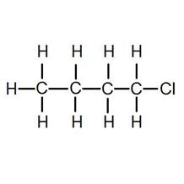Q9.1 Halogenoalkanes

What is the name of this halogenoalkane?

How could you make it from butan-1-ol?

Q9.2 Alcohols

How could you make ethanol from ethene?

How does ethanol react with sodium, in what ways is this a) similar to the reaction with water, b) different to the reaction with water?

Q9.3 Aldehydes and ketones

Draw the structures of a) propanal b) propanone

How are these two functional groups different?

**New Chemistry Topics- Have a go if you want to get ahead- Optional (but only if you are confident in your GCSE knowledge!)**

**You have met some background ideas about these concepts at GCSE but now we take things a little further and start introducing some new ideas you will meet in A level Chemistry. Challenge yourself, have a go and see how you get on- use the links for help and guidance but don’t panic if you don’t fully ‘get it’ we will go over these topics in the Autumn term...**

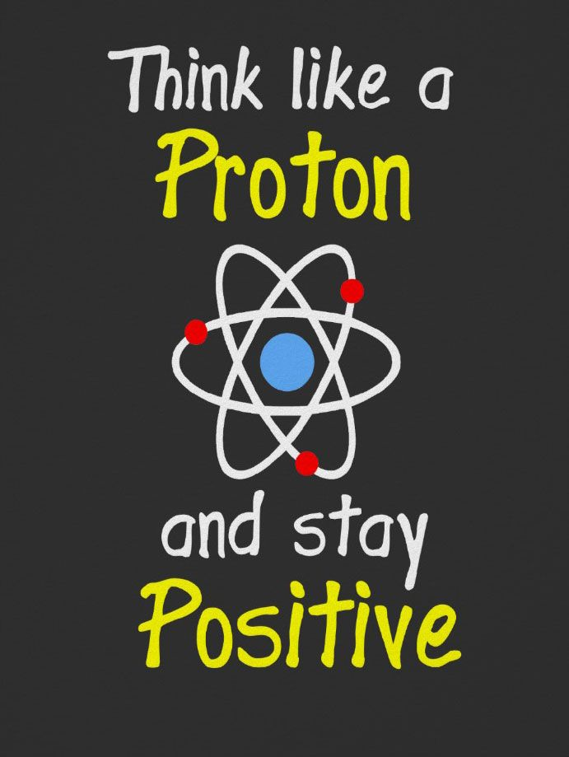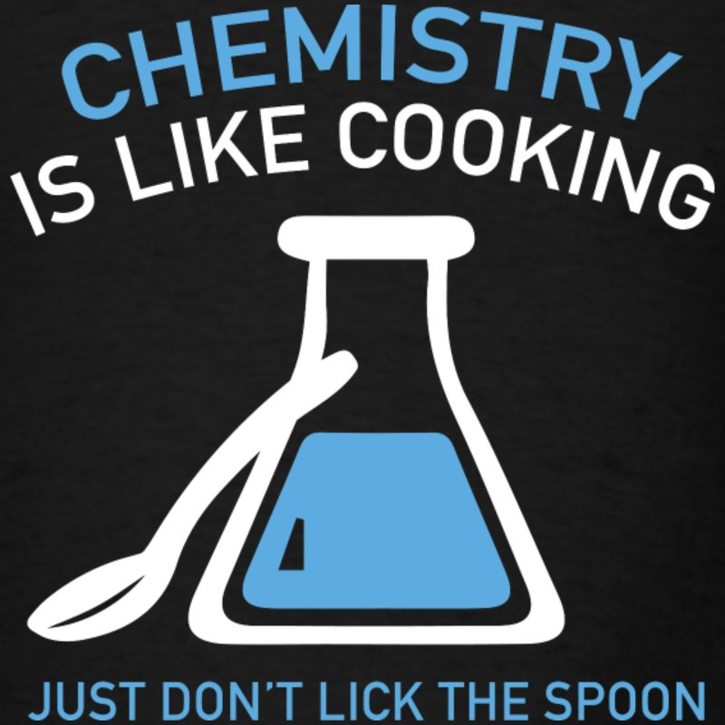

**New Chemistry topic 1 – Isotopes and mass**

You will remember that an isotopes are elements that have differing numbers of neutrons. Hydrogen has 3 isotopes; $H_{1}^{1}$ $H_{1}^{2}$ $H_{1}^{3}$

Isotopes occur naturally, so in a sample of an element you will have a mixture of these isotopes. We can accurately measure the amount of an isotope using a **mass spectrometer**. You will need to understand what a mass spectrometer is and how it works at A level. You can read about a mass spectrometer here:



<http://bit.ly/pixlchem4>

<http://filestore.aqa.org.uk/resources/chemistry/AQA-7404-7405-TN-MASS-SPECTROMETRY.PDF>

Q3.1 What must happen to the atoms before they are accelerated in the mass spectrometer?

Q3.2 Explain why the different isotopes travel at different speeds in a mass spectrometer.

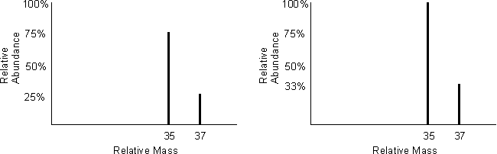A mass spectrum for the element chlorine will give a spectrum like this:

75% of the sample consist of chlorine-35, and 25% of the sample is chlorine-37.

Given a sample of naturally occurring chlorine ¾ of it will be Cl-35 and ¼ of it is Cl-37. We can calculate what the **mean** mass of the sample will be:

Mean mass = 75 x 35 + 25 x 37 = 35.5

100 100

If you look at a periodic table this is why chlorine has an atomic mass of 35.5.

<http://www.avogadro.co.uk/definitions/ar.htm>

An A level periodic table has the masses of elements recorded much more accurately than at GCSE. Most elements have isotopes and these have been recorded using mass spectrometers.

**GCSE A level**

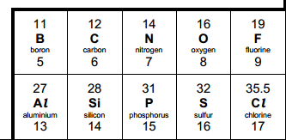 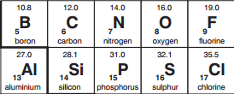

**GCSE → A Level transition**

**Student sheet**

Given the percentage of each isotope you can calculate the mean mass which is the accurate atomic mass for that element.

Q3.3 Use the percentages of each isotope to calculate the accurate atomic mass of the following elements.

1. Antimony has 2 isotopes: Sb-121 57.25% and Sb-123 42.75%
2. Gallium has 2 isotopes: Ga-69 60.2% and Ga-71 39.8%
3. Silver has 2 isotopes: Ag-107 51.35% and Ag-109 48.65%
4. Thallium has 2 isotopes: Tl-203 29.5% and Tl-205 70.5%
5. Strontium has **4** isotopes: Sr-84 0.56%, Sr-86 9.86%, Sr-87 7.02% and Sr-88 82.56%

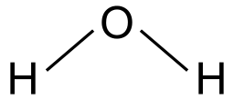**New Chemistry topic 2– The shapes of molecules and bonding.**

Have you ever wondered why your teacher drew a water molecule like this?

The lines represent a covalent bond, but why draw them at an unusual angle?

If you are unsure about covalent bonding, read about it here:

<http://www.chemguide.co.uk/atoms/bonding/covalent.html#top>

At A level you are also expected to know how molecules have certain shapes and why they are the shape they are.

You can read about shapes of molecules here:

<http://www.chemguide.co.uk/atoms/bonding/shapes.html#top>

Q4.1 Draw a dot and cross diagram to show the bonding in a molecule of aluminium chloride (AlCl3)

Q4.2 Draw a dot and cross diagram to show the bonding in a molecule of ammonia (NH3)

Q4.3 What is the shape and the bond angles in a molecule of methane (CH4)?



***Chemistry***

**Useful Maths skills (must complete)**

1. **Core mathematical skills**

A practical chemist must be proficient in standard form, significant figures, decimal places, SI units, and unit conversion.

* 1. **Standard form**

In science, very large and very small numbers are usually written in standard form. Standard form is writing a number in the format A × 10x where A is a number from 1 to 10 and x is the number of places you move the decimal place.

For example, to express a large number such as 50 000 mol dm−3 in standard form, A = 5 and x = 4 as there are four numbers after the initial 5.

Therefore, it would be written as 5×104 mol dm−3.

To give a small number such as 0.000 02 Nm2 in standard form, A = 2 and there are five numbers before it so x = −5.

So it is written as 2×10−5 Nm2.

***Practice questions***

1. Change the following values to standard form.

**a** boiling point of sodium chloride: 1413 °C

**b** largest nanoparticles: 0.0 001×10−3 m

**c** number of atoms in 1 mol of water: 1806×1021

1. Change the following values to ordinary numbers.

**a** 5.5×10−6 **b** 2.9×102 **c** 1.115×104 **d** 1.412×10−3 **e** 7.2×101

* 1. **Significant figures and decimal places**

In chemistry, you are often asked to express numbers to either three or four significant figures. The word significant means to ‘have meaning’. A number that is expressed in significant figures will only have digits that are important to the number’s precision.

It is important to record your data and your answers to calculations to a reasonable number of significant figures. Too many and your answer is claiming an accuracy that it does not have, too few and you are not showing the precision and care required in scientific analysis.

For example, 6.9301 becomes 6.93 if written to three significant figures. Likewise, 0.000 434 56 is 0.000 435 to three significant figures.

Notice that the zeros before the figure are *not* significant – they just show you how large the number is by the position of the decimal point. Here, a 5 follows the last significant digit, so just as with decimals, it must be rounded up.

Any zeros between the other significant figures are significant. For example, 0.003 018 is

0.003 02 to three significant figures.

Sometimes numbers are expressed to a number of decimal places. The decimal point is a place holder and the number of digits afterwards is the number of decimal places.

For example, the mathematical number pi is 3 to zero decimal places, 3.1 to one decimal place,

3.14 to two decimal places, and 3.142 to three decimal places.



**GCSE → A Level transition**

**Student sheet**

***Chemistry***

***Practice questions***

1. Give the following values in the stated number of significant figures (s.f.).

**a** 36.937 (3 s.f.) **b** 258 (2 s.f.) **c** 0.043 19 (2 s.f.) **d** 7 999 032 (1 s.f.)

1. Use the equation:

number of molecules = number of moles × 6.02 × 1023 molecules per mole

to calculate the number of molecules in 0.5 moles of oxygen. Write your answer in standard form to 3 s.f.

1. Give the following values in the stated number of decimal places (d.p.).

**a** 4.763 (1 d.p.) **b** 0.543 (2 d.p.) **c** 1.005 (2 d.p.) **d** 1.9996 (3 d.p.)

**1.3 Converting units**

Units are defined so that, for example, every scientist who measures a mass in kilograms uses the same size for the kilogram and gets the same value for the mass. Scientific measurement depends on standard units – most are *Système International* (SI) units.

If you convert between units and round numbers properly it allows quoted measurements to be understood within the scale of the observations.

|  |  |  |
| --- | --- | --- |
| **Multiplication factor** | **Prefix** | **Symbol** |
| 109 | giga | G |
| 106 | mega | M |
| 103 | kilo | k |
| 10–2 | centi | c |
| 10–3 | milli | m |
| 10–6 | micro | µ |
| 10–9 | nano | n |

Unit conversions are common. For instance, you could be converting an enthalpy change of 488 889 J mol−1 into kJ mol−1. A kilo is 103 so you need to divide by this number or move the decimal point three places to the left.

488 889 ÷ 103 kJ mol−1 = 488.889 kJ mol−1

Converting from mJ mol−1 to kJ mol−1, you need to go from 103 to 10−3, or move the decimal point six places to the left.

333 mJ mol−1 is 0.000 333 kJ mol−1

If you want to convert from 333 mJ mol−1 to nJ mol−1, you would have to go from 10−9 to 10−3, or move the decimal point six places to the right.

333 mJ mol−1 is 333 000 000 nJ mol−1

***Practice questions***

**6** Calculate the following unit conversions.

**a** 300 µm to m

**b** 5 MJ to mJ

**c** 10 GW to kW

**Careers- Optional**

**You may already have an idea about what you want to do beyond GCSE and A levels or you may have chosen your A level courses based on the topics you enjoy, either way investigating the types of careers that a Chemistry course can lead you into might surprise you and inspire you.**

**Visit the following websites to take a look: -**

<https://edu.rsc.org/future-in-chemistry?_ga>

<https://www.prospects.ac.uk/careers-advice/what-can-i-do-with-my-degree/chemistry>

**Research activities (pick one)**

Use your online searching abilities to see if you can find out as much about the topic as you can. Remember if you are a prospective A level chemist, you should aim to push **your** knowledge.

**Turn your research into a poster that you can present to a small group in the first few lessons back.**

**Task 1: The chemistry of fireworks**

What are the component parts of fireworks? What chemical compounds cause fireworks to explode? What chemical compounds are responsible for the colour of fireworks?

**Task 2: Why is copper sulfate blue?**

Copper compounds like many of the transition metal compounds have got vivid and distinctive colours – but why?

**Task 3: Aspirin**

What was the history of the discovery of aspirin, how do we manufacture aspirin in a modern chemical process?

**Task 4: The hole in the ozone layer**

Why did we get a hole in the ozone layer? What chemicals were responsible for it? Why were we producing so many of these chemicals? What is the chemistry behind the ozone destruction?

**Task 5: ITO and the future of touch screen devices**

ITO – indium tin oxide is the main component of touch screen in phones and tablets. The element indium is a rare element and we are rapidly running out of it. Chemists are desperately trying to find a more readily available replacement for it. What advances have chemists made in finding a replacement for it?

**Task 6: Battery Power**

Find out how different types of batteries work e.g. lithium ion batteries, rechargeable batteries, alkaline batteries etc.. Find out about current research into new types of batteries including those being developed to store electricity made by renewables such as wind/solar/tidal power.