

Adapted by CLCC June 2020

Using resources from Oxford A level resources (Kerboodle)

**Transition Pack for**

**Level 3 AAQ Applied Science**

**(summer pack)**

**Get ready for Science!**

**A guide to help you get ready for Level 3 AAQ Applied Science, including everything from topic guides to online learning courses.**

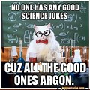

**The following tasks are for you to complete over the summer holidays to help you prepare for the NEW Level 3 AAQ Applied Science course. Please bring the completed booklets with you to your first lesson. Some tasks are general skills that check that you are confident with some ideas met at GCSE in terms of Maths skills and Practical skills in Science.**

**Don’t worry too much if you are not sure about some of these new ideas we will cover them during the year but it will give you a head start and hopefully you will find them interesting.**

**If you do have any questions about the tasks in the booklet or the course please email** Miss Carson [mcarson@clcc.college](mailto:mcarson@clcc.college)

Deadline 1st September 2025.

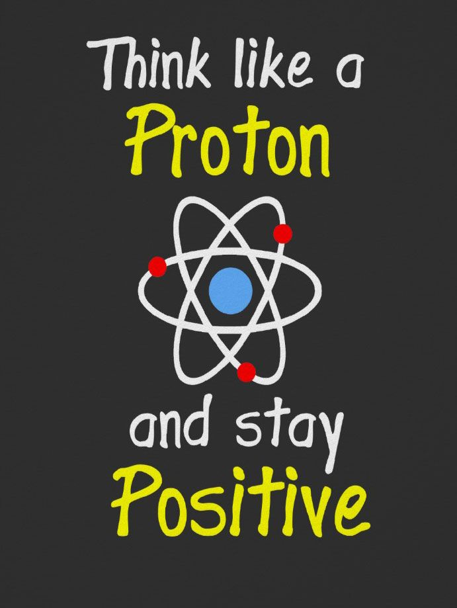

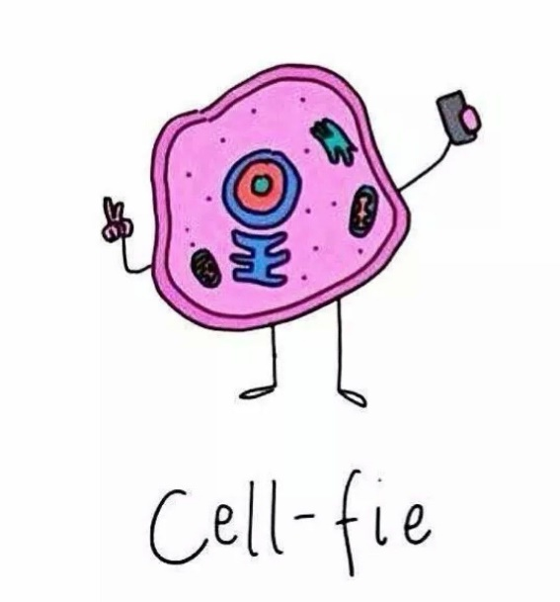

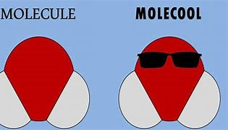

**AAQ BTEC Level 3 National Extended Certificate**

**in Applied Science**

**Teachers of Applied Science**

Course leader Miss Carson Biology components [mcarson@clcc.college](mailto:mcarson@clcc.college)

Mrs Mifflin Chemistry components [hmifflin@clcc.college](mailto:hmifflin@clcc.college)

Mr Rowe Physics Components [jrowe@clcc.college](mailto:jrowe@clcc.college)

This course covers all three science specialisms of Biology, Chemistry and Physics, focusing on their application in the real world. Science is everywhere and developing an appreciation and understanding of science along with the skill base that this course develops is a highly desirable quality that employers and Higher Education appreciate.

Studying this course will help you develop the transferable and higher order skills which are valued by higher education providers and employers. Students will develop skills including how to plan investigations, collecting, analysing, and presenting data and communicating results which support some of the skills learners need to progress to higher education, employment, self-employment or training. Students develop into resilient learners who are able to manage their time and workload, meet deadlines and think for themselves.

**Course outline**

The course content is split into units of work:

* 1 Principles and Applications of Biology
* 2 Principles and Applications of Chemistry
* 3 Principles and Applications of Physics
* 4 Practical Scientific Procedures and Techniques
* 5 Science Investigation Skills
* 6 Contemporary Issues in Science

**How am I assessed?**

In this course, which is equivalent in size to one A-Level, students must complete five units: • two mandatory externally assessed units • one mandatory non-examined assessment (NEA) unit • two optional NEA units

**Transition from GCSE to Level 3 Applied Science**

Moving from GCSE Science to A Level can be a daunting leap. You’ll be expected to remember a lot more facts, equations, and definitions, and you will need to learn new maths skills and develop confidence in applying what you already know to unfamiliar situations.

This work pack aims to give you a head start by helping you:

* to pre-learn some useful knowledge from the first chapters of your A Level course
* understand and practice **some of the** maths skills you’ll need.

**Pre-Knowledge Topics - All must be completed**

**You have come across most of these concepts to some degree at GCSE but it is really important you understand them as they are fundamental ideas in Applied Science. For each of the following topics, you need to answer the questions; either as a list or as a mind map – try and be imaginative with your layout.**

**When you complete your notes, spend time Learning the answers by covering the answers with a piece of paper and** **write as many answers as you can. Check and repeat.**

**If you find topics you are still unsure about, please use websites to aid your understanding.**

**Chemistry (spend about 2 hours on this)**

**Atomic Structure**

1. What is an element?
2. What is a compound?
3. What is a mixture?
4. What charge does a proton have?
5. What mass does a proton have?
6. Where will you find a proton?
7. What charge does a Neutron have?
8. What mass does a Neutron have?
9. Where will you find a Neutron?
10. What charge does an electron have?
11. What mass does an electron have?
12. Where will you find an electron?
13. What does the atomic number (proton number) tell you?
14. What can you work out from the relative atomic mass?
15. How are electrons arranged in an atom?
16. What does the periodic table group number tell you about an atoms electronic structure?
17. What does the period of an element in the periodic table tell you about the atoms electronic structure?
18. What is an ion?
19. What charge do metal ions have?
20. What charge do non-metal ions have?
21. What is the name given to group 0?
22. What are the key properties of group 0 elements and why do they have these properties?

**Chemical Quantities**

1. What is the relative atomic mass of an element?
2. What is the atomic mass of Na?
3. What is the atomic mass of Br?
4. How do you calculate relative formula mass?
5. What is the relative formula mass of H2O?
6. What is the relative formula mass for MgCl2?
7. What is the relative formula mass of CH4?
8. What is the law of conservation of mass?
9. Why might the mass appear to decrease during a reaction?
10. Why might the mass appear to increase in a reaction?

**Biology (spend about 1 hour on this)**

**Cell Biology**

1. What are the two types of cell?
2. What type of cells are we made up of?
3. What type of cells are bacterial made from?
4. What is the function of the nucleus?
5. What is the function of the cell membrane?
6. What is the function of the chloroplast?
7. What is the function of the mitochondria?
8. What is the function of the ribosomes?
9. What is the function of the vacuole?
10. What are the three differences between an animal and a plant cell?
11. Which cell is the smallest: bacterial, animal or plant?
12. What is an organelle?
13. Do eukaryotic cells have a nucleus?
14. Which specialised cell has no nucleus to create more room for haemoglobin?
15. Which specialised cell has a tail to help it swim?
16. Which specialised cell carries electrical signals?
17. Which specialised cell can contract and relax?
18. Which specialised cell is hollow and can transport water?
19. Which specialised cell has a large surface area to absorb water from the soil?
20. What do we call a group of cells?
21. Why do cells need sugar?

**Physics (spend about 1 hour on this)**

At GCSE you have studied different types of waves and used the wave equation to calculate speed, frequency and wavelength. You will also have studied reflection and refraction.

Use the following links to review this topic **and make notes.** Make sure your notes contain the answers to the questions below.

<https://www.khanacademy.org/science/physics/mechanical-waves-and-sound/mechanical-waves/v/introduction-to-waves>

**Waves**

1. What are the two types of wave?
2. Are sound waves longitudinal or transverse?
3. Are light waves longitudinal or transverse?
4. What is the formula for calculating period?
5. The distance between one point on a wave and the same point on the next wave is?
6. The number of complete waves passing a certain point each second is?
7. What is the unit for frequency?
8. The type of wave that has vibrations perpendicular (at right angles) to the direction of energy transfer is?
9. The type of wave that has vibrations in same direction as the energy transfer is?
10. What is the formula to calculate wave speed?
11. What is the unit for wavelength?
12. Light waves that we see are part of what group of waves?
13. What do waves transfer?
14. What happens to the temperature of the object hit by an infrared wave?
15. List the 7 groups of waves that form the EM spectrum, in order of decreasing wavelength.
16. Which EM waves have the lowest frequency? Which EM waves have the highest frequency?
17. Which EM waves have a higher frequency than microwaves?
18. What can be said about the speed of all the waves in the EM spectrum?
19. Which wave has a high frequency than radio waves but lower than IR?
20. Which wave has a higher frequency than visible light but lower than x-rays?

**Seneca Learning (spend about 2 hours on this)**

Your next task is to complete the Seneca GCSE **refresher sections** for Physics and Biology (you don’t need to do the taster sections). As you do the GCSE refresher pages complete for us a revision aid of your choice – I suggest a mind map but if you prefer you can do a fact sheet, flash cards or even a power point.

Physics is at <https://app.senecalearning.com/classroom/course/eb1a286f-2cf3-486d-a591-5494d8b256c7/section/6254010a-c9e2-477d-a457-2605b09d8af6/session>

Biology is at <https://app.senecalearning.com/classroom/course/76917ca0-ac10-43c9-8742-e49b861417b2/section/85450ad6-7203-4528-8be0-8a1eac5eff33/session>