

Adapted by CLCC June 2020

Using resources from Oxford A level resources (Kerboodle)

**Transition Pack for A Level Physics**

**Get ready for A-level!**

**A guide to help you get ready for A-level Physics, including everything from topic guides to online learning courses.**



© Copyright The PiXL Club Ltd, 2016

© Oxford University Press 2019

Preparing to study

Level Physics

This pack contains a programme of activities and resources to prepare you to start an A level in Physics in September. It is designed for you to complete throughout the remainder of the summer term to help you prepare for your course in September.

**The following tasks are for you to complete over the summer holidays to help you prepare for the A level Physics course. Please bring the completed booklets with you to your first lesson. Some tasks are general skills that check that you are confident with some ideas met at GCSE in terms of Maths and Practical skills in Science.**

**Don’t worry too much if you are not sure about some of the new ideas covered - we will cover them during the year but it will give you a head start and hopefully you will find them interesting.**

**If you do have any questions about the tasks in the booklet or the course please email Mrs Fox – I’m always happy to** [**kfox@clcc.college**](mailto:kfox@clcc.college)

Deadline 1st September 2025.

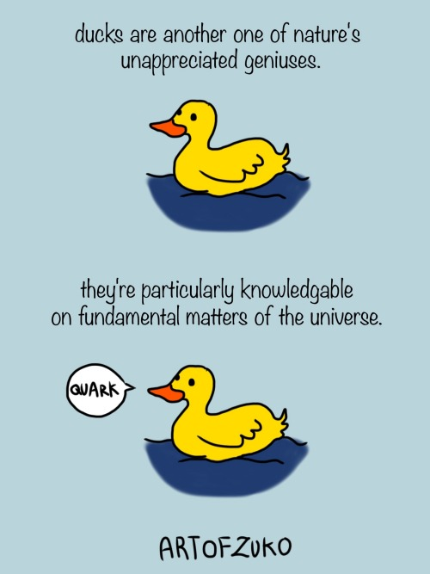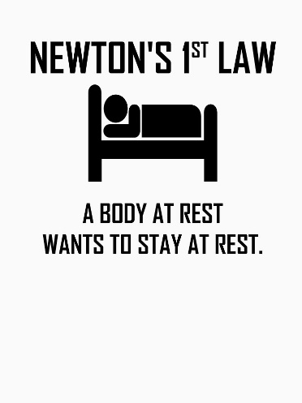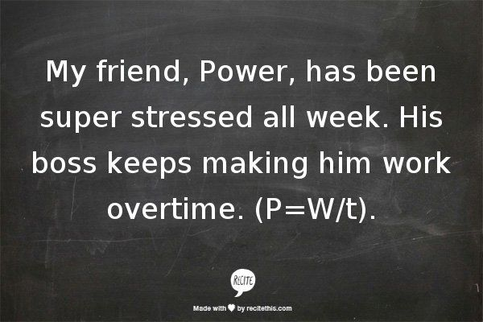

**So what’s it like to study A level Physics at Countesthorpe Academy?**

Your teachers: Mr Rowe [jrowe@clcc.college](mailto:jrowe@clcc.college)

Mrs Fox (Head of Science) [kfox@clcc.college](mailto:kfox@clcc.college)

Your course:

* Following OCR A (from 2015) exam board
* All students are expected to complete the full A level course, we do not sit AS level exams.

To find out more about the course or view the specification use this link:

<https://www.ocr.org.uk/qualifications/as-and-a-level/physics-a-h156-h556-from-2015/>

The six modules are each divided into key topics:

#### Module 1: Development of practical skills in physics

* Practical skills assessed in a written examination
* Practical skills assessed in the practical endorsement

#### Module 2: Foundations in physics

* Physical quantities and units
* Making measurements and analysing data
* Nature of quantities

#### Module 3: Forces and motion

* Motion and Forces in action
* Work, energy and power
* Materials
* Newton’s laws of motion and momentum

#### Module 4: Electrons, waves and photons

* Charge and current
* Energy, power and resistance
* Electrical circuits
* Waves
* Quantum physics

#### Module 5: Newtonian world and astrophysics

* Thermal physics
* Circular motion
* Oscillations
* Gravitational fields
* Astrophysics and cosmology

#### Module 6: Particles and medical physics

* Capacitors
* Electric fields
* Electromagnetism
* Nuclear and particle physics
* Medical imaging

## How am I assessed?

Progress is monitored by regular end of chapter tests and assessed homework plus support lessons to be completed outside of the laboratory in student’s personal study periods. There are 3 exams at the end of the course: Modelling physics, Exploring physics and Unified physics.

**Transition from GCSE to A Level**

Moving from GCSE Science to A Level can be a daunting leap. You’ll be expected to remember a lot more facts, equations, and definitions, and you will need to learn new maths skills and develop confidence in applying what you already know to unfamiliar situations.

This worksheet aims to give you a head start by helping you:

* to pre-learn some useful knowledge from the first chapters of your A Level course
* understand and practice some of the maths skills you’ll need.

**Pre-Knowledge Topics**

**Below are topics that are essential foundations for you study of A-Level Physics. Each topic has example questions and links where you can find our more information as you prepare for next year. You have come across most of these concepts to some degree at GCSE but it is really important you understand them as they are fundamental ideas in Physics. For each of the following topics, you need to use the resources suggested to produce one page of notes. Please use the Flipped Learning sheet – one for each topic. If you find topics you are still unsure about, please use other websites to aid your understanding. Some of the research questions are followed with questions to check your knowledge. You could always email if you get really stuck.**

**Symbols and Prefixes**

At A level, unlike GCSE, you need to remember all symbols, units and prefixes. Below is a list of quantities you may have already come across and will be using during your A level course. You need to learn these!

|  |  |  |
| --- | --- | --- |
| **Quantity** | **Symbol** | **Unit** |
| Velocity | v | ms-1 |
| Acceleration | a | ms-2 |
| Time | t | S |
| Force | F | N |
| Resistance | R | Ω |
| Potential difference | V | V |
| Current | I | A |
| Energy | E or W | J |
| Pressure | P | Pa |
| Momentum | p | kgms-1 |
| Power | P | W |
| Density | *ρ* | kgm-3 |
| Charge | Q | C |

|  |  |  |
| --- | --- | --- |
| **Prefix** | **Symbol** | **Power of ten** |
| Nano | n | x 10-9 |
| Micro | μ | x 10-6 |
| Milli | m | x 10-3 |
| Centi | c | x 10-2 |
| Kilo | k | x 103 |
| Mega | M | x 106 |
| Giga | G | x 109 |

**Solve the following:**

1. How many metres in 2.4 km?
2. How many Joules in 8.1 MJ?
3. Convert 326 GW into W.
4. Convert 54 600 mm into m.
5. How many grams in 240 kg?
6. Convert 0.18 nm into m.
7. Convert 632 nm into m. Express in standard form.
8. Convert 1002 mV into V. Express in standard form.
9. How many eV in 0.511 MeV? Express in standard form.
10. How many m in 11 km? Express in standard form.

**Standard Form**

At A level quantity will be written in standard form, and it is expected that your answers will be too. This means answers should be written as ….x 10y. E.g. for an answer of 1200kg we would write 1.2 x 103kg. For more information visit:

[Module 7 (M7) – Algebra - Standard form - BBC Bitesize](https://www.bbc.co.uk/bitesize/articles/z4v63qt#z2wgjfr)

1. Write 2530 in standard form.
2. Write 280 in standard form.
3. Write 0.77 in standard form.
4. Write 0.0091 in standard form.
5. Write 1 872 000 in standard form.
6. Write 12.2 in standard form.
7. Write 2.4 x 10 2 as a normal number.
8. Write 3.505 x 10 1 as a normal number.
9. Write 8.31 x 10 6 as a normal number.
10. Write 6.002 x 10 2 as a normal number.
11. Write 1.5 x 10-4 as a normal number.
12. Write 4.3 x 103 as a normal number.

**Rearranging formulae**

This is something you will have done at GCSE and it is crucial you master it for success at A level.

For a recap of GCSE watch the following links:

[www.khanacademy.org/math/algebra/one-variable-linear-equations/old-school-equations/v/solving-for-a-variable](http://www.khanacademy.org/math/algebra/one-variable-linear-equations/old-school-equations/v/solving-for-a-variable)

[www.youtube.com/watch?v=_WWgc3ABSj4](http://www.youtube.com/watch?v=_WWgc3ABSj4)

**Rearrange the following:**

1. E=m x g x h to find h
2. Q= I x t to find I
3. E = ½ m v2 to find m
4. E = ½ m v2 to find v
5. v = u + at to find u
6. v = u + at to find a
7. v2 = u2 +2as to find s
8. v2 = u2 +2as to find u

**Significant figures**

At A level you will be expected to use an appropriate number of significant figures in your answers. The number of significant figures you should use is the same as the number of significant figures in the data you are given. You can never be more precise than the data you are given so if that is given to 3 significant your answer should be too. E.g. Distance = 8.24m, time = 1.23s therefore speed = 6.75m/s

The website below summarises the rules and how to round correctly.

<http://www.purplemath.com/modules/rounding2.htm>

**Give the following to 3 significant figures:**

1. 3.4527
2. 40.691
3. 0.838991
4. 1.0247
5. 59.972

**Calculate the following to a suitable number of significant figures:**

1. 63.2/78.1
2. 39+78+120
3. (3.4+3.7+3.2)/3
4. 0.0256 x 0.129
5. 592.3/0.1772

**Forces and Motion**

At GCSE you studied forces and motion and at A level you will explore this topic in more detail so it is essential you have a good understanding of the content covered at GCSE. You will be expected to describe, explain and carry calculations concerning the motion of objects.

The websites below cover Newton’s laws of motion and have links to these in action.

<http://www.physicsclassroom.com/Physics-Tutorial/Newton-s-Laws>

**Sketch a velocity-time graph showing the journey of a skydiver after leaving the plane to reaching the ground. Mark on terminal velocity.**

**Energy**

For these questions answer in a way that works for you – Q+A; mind map; flash cards; on the computer – it is up to you.

1. List 8 stores of energy
2. What is the formula for kinetic energy?
3. What is the formula for gravitational potential energy?
4. What is the unit for gravity?
5. What happens to the store of kinetic energy and gravitational potential energy as an object falls?
6. What is the formula for elastic energy?
7. What is the unit for extension?
8. What is the unit for the spring constant?
9. How many grams are in 1 kilo gram?
10. What does ‘conservation of energy’ mean?
11. What is power?
12. What is the unit for power?
13. What is the unit of work done?
14. How can we reduce unwanted energy transfer?
15. What is the equation for calculating efficiency?

**Forces**

For these questions answer in a way that works for you – Q+A; mind map; flash cards; on the computer – it is up to you.

1. What is speed and how is it different to velocity?
2. What is a vector quantity? Give an example
3. What is a scalar quantity? Give an example
4. What is the name given to forces on objects that are physically touching? Give an example
5. What is the name given to forces on objects are physically separated? Give an example
6. What is the difference between mass and weight?
7. What is the formula for weight?
8. What is the unit for force?
9. What is acceleration?
10. What is terminal velocity?
11. What is Newton’s first law of motion?
12. What is Newton’s second Law of Motion?
13. What is the formula linking force, spring constant and extension?
14. What happens to a spring after it exceeds its limit of proportionality?
15. What is the formula for elastic potential energy?

**Electricity**

At A level you will learn more about how current and voltage behave in different circuits containing different components. You should be familiar with current and voltage rules in a series and parallel circuit as well as calculating the resistance of a device.

<http://www.physicsclassroom.com/class/circuits>

For these questions answer in a way that works for you – Q+A; mind map; flash cards; on the computer – it is up to you.

1. What is the circuit diagram for a cell? What about for a battery?
2. What is the circuit diagram for a filament lamp or bulb?
3. What is the circuit diagram for a LED?
4. What is the circuit diagram for a resistor? what about for a variable resistor?
5. What is the circuit diagram for an ammeter?
6. What is the circuit diagram for a diode?
7. What is the circuit diagram for a LDR?
8. What is the circuit diagram for a thermistor?
9. Should an ammeter be placed in series or in parallel in a circuit?
10. Should a voltmeter be placed in series or in parallel in a circuit?
11. What is current and what is it’s unit?
12. What device do you use to measure current with?
13. What is potential difference also known as and what is the unit for potential difference?
14. What is resistance? And what is the unit for resistance?
15. What is the voltage, current graph for ohmic conductor?
16. Explain the voltage current graph for filament lamp
17. What happens to the resistance of an LDR as light intensity increased?

**18** Add the missing ammeter readings on the circuits below.

**19)** Explain why the second circuit has more current flowing than the first.

**20)** Add the missing potential differences to the following circuits

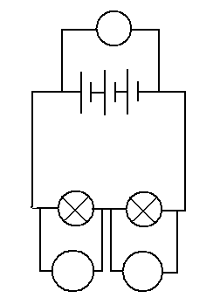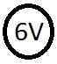

**Waves**

You have studied different types of waves and used the wave equation to calculate speed, frequency and wavelength. You will also have studied reflection and refraction.

Use the following links to review this topic. **Make a revision page on this topic**

[Waves - BBC Bitesize](https://www.bbc.co.uk/bitesize/articles/zcsg3j6)

<https://www.khanacademy.org/science/physics/mechanical-waves-and-sound/mechanical-waves/v/introduction-to-waves>

<https://www.khanacademy.org/science/physics/mechanical-waves-and-sound/mechanical-waves/v/introduction-to-waves>

**Waves**

For these questions answer in a way that works for you – Q+A; mind map; flash cards; on the computer – it is up to you.

1. What are the two types of wave? Give examples of each
2. The type of wave that has vibrations perpendicular (at right angles) to the direction of energy transfer is?
3. The type of wave that has vibrations in same direction as the energy transfer is?
4. What is the formula for calculating period?
5. Draw a wave to illustrate; wavelength and amplitude.
6. The number of complete waves passing a certain point each second is called? And what is it’s unit?
7. What is the formula to calculate wave speed?
8. What happens to the temperature of the object hit by an infrared wave?
9. List the 7 groups of waves that form the EM spectrum, in order of decreasing wavelength.
10. Which EM waves have the lowest frequency?
11. Which EM waves have the longest wavelength?
12. What can be said about the speed of all the members of the EM spectrum?
13. What is a dotted line drawn at right angles to the boundary on a ray diagram called?
14. How could you investigate the reflection and refraction of light by different substances?

**Seneca Learning (spend about 2 hours on this)**

Your next task is to complete the Seneca GCSE refresher and A Level taster sections. The site says it is for the AQA exam board but the Physics content is the same for OCR.

[Seneca - Learn 2x Faster (senecalearning.com)](https://app.senecalearning.com/classroom/course/eb1a286f-2cf3-486d-a591-5494d8b256c7/section/6254010a-c9e2-477d-a457-2605b09d8af6/section-overview)

As you do the GCSE refresher pages complete for us a revision aid of your choice – we suggest a mind map but if you prefer you can do a fact sheet, flash cards or even a power point.

As you complete the A level Taster section pages complete for us a fact sheet of new information. Again I suggest a mind map but if you prefer you can do a fact sheet, flash cards or even a power point.