

A Level Media Studies
Summer workbook

Complete either task 1 and 4 or task 2 and 3 of the four activities available within this booklet.

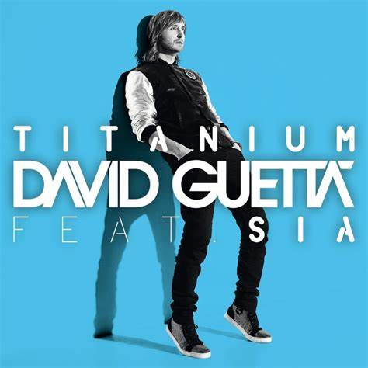


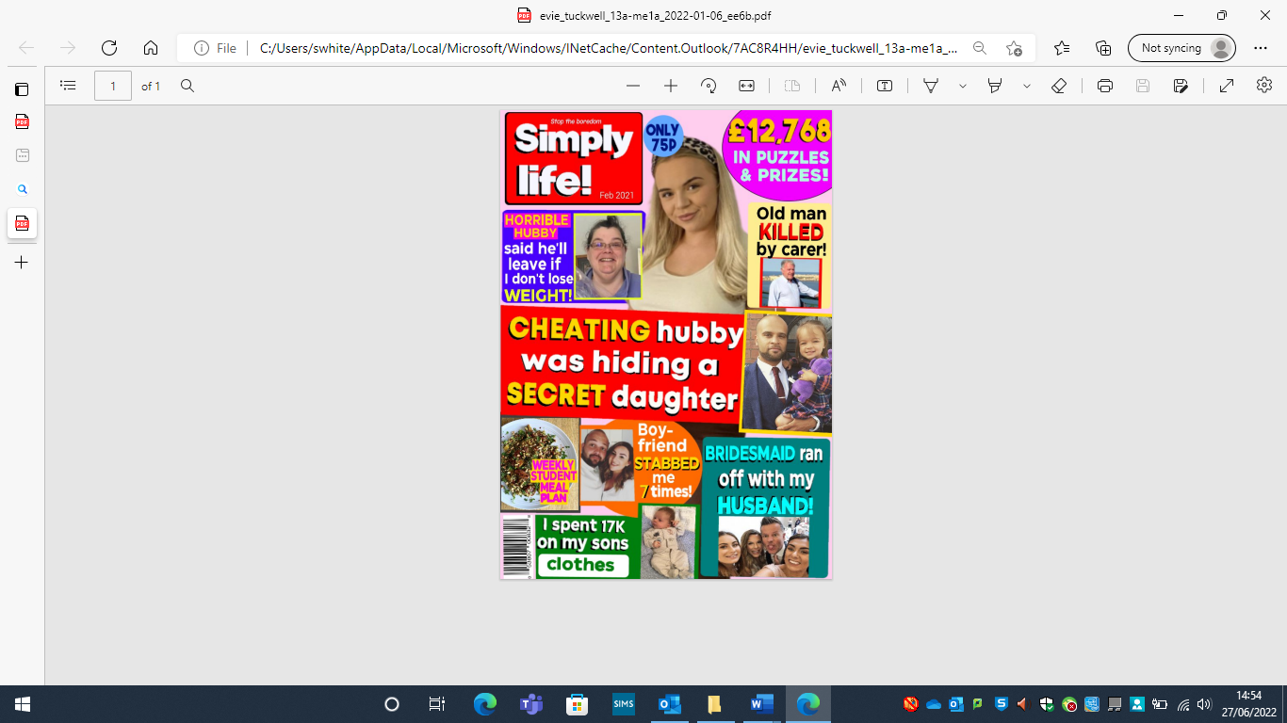

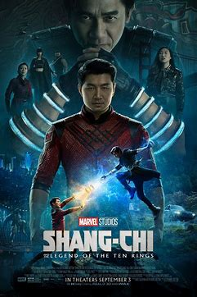

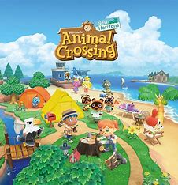
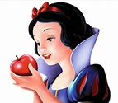

Name:

A-Level Media Studies

Welcome to A-Level Media Studies, you’ll find there are plenty of areas that will be familiar to you if you studied the subject at GCSE level, however you’ll also find there are lots of new ideas and concepts that you will not have covered. Don’t be alarmed though if you’ve never studied Media before they’ll be introduced to you and guided through the foundations on which the course is built.

KS5 Media Studies is underpinned by four KEY CONCEPTS, these are:
- Media Language
- Representation
- Audience
- Media Industries

You will be expected to read around each of the topics you study and form your own opinions and views on these. It is not enough to regurgitate what your teacher tells you in your lessons, you will need to form your own views and opinions alongside these.

What makes a successful student at A-Level?
The one thing that the majority of students who achieve highly at the end of the course have in common is that they’re independent learners who have a desire to expand their own knowledge and understanding of the topics covered in class.

Why study Media Studies?
- Comprehensive and integrated coverage of media theory and practise
- Focus on new technologies
- Covers audiences as both producers and consumers of media texts
- Opportunities for you to investigate what interests you.
- Choice of cross-media studies linking with other subjects such as art, IT, sociology, drama and psychology.
- Emphasis on contemporary issues and debates
- You’ll be working independently and advance your skills to be a self-sufficient learner in preparation for further study at University or other career avenues.
- Develop a range of transferable skills.


Recommended reading:

- Media Theory for A Level: The Essential Revision Guide by Mark Dixon.

- OCR A Level Media Studies website – set text fact sheets, example essays and resources.

- My Revision Notes: OCR A Level Media Studies Second Edition by Michael Rogers

Specification overview
Leaner take all Components 1, 2 and 3 to be awarded the OCR A Level in Media Studies.
Content Overview | Assessment Overview
Section A: News and Online Media  This section consists of two linked in-depth studies that focus on contemporary news in the UK, requiring learners to explore how and why newspapers and their online counterparts are evolving as media products and the relationship between both online and offline news. Learners must select from a list set by OCR.  Section B: Media Language and Representation  Learners will explore media language and representation through media products set by OCR in the following media forms:  - magazines  - advertising and marketing and  - music videos | Media messages  (Paper 1)  70 marks  2 hours  Written paper | 35% of  total  A level
Section A: Media Industries and Audiences  Learners will explore media industries and audiences through media products set by OCR for:  - Radio  - Video games  - Film*  *Film to be studies in relation to media industry only  Section B: Long Form Television Drama  Learners will engage in one in-depth study of television as an evolving, global media form. Learners must study one complete episode of a contemporary English language long form TV drama and one complete episode of a non-English language long form TV drama to inform their study. Leaners must select from lists set by OCR. | Evolving media  (Paper 2)  70 marks  2 hours  Written paper | 35% of  total  A level
Learners will create a cross-media product in response to an OCR set brief.  A range of briefs are set and learners can choose based on their own knowledge and interests. | Making media  (03)  60 marks  NEA | 30% of  total  A Level

Current choice of set texts
Media form | Set product | Area to be studied | To be studied in
Film | Snow White and the Seven Dwarfs (1937)  AND  Shang-Chi and the Legend of the Ten Rings (2021) | - Media industries  - Economic and historical contexts | Paper 2: Evolving Media  Section A
Advertising and marketing | Poster advertisements for:  River Island ‘Labels for Clothes’ (clothing), Dove ‘Too Many Cooks’ Beautifully Real Moms (grooming), Shelter (charity). | - Media language  - Media representations  - Social and cultural contexts | Paper 1: Media Messages  Section B
Radio | One complete episode of The BBC Radio One Breakfast Show | - Media industries  - Media Audiences  - Economic, political and cultural contexts | Paper 2: Evolving Media  Section A
Magazines | Two front covers of The Big Issue | - Media language  - Media representations  - Social, cultural and politic contexts | Paper 1: Media Messages  Section B
Video games | Animal Crossing: New Horizons (2020), PEGI 3 | - Media industries  - Media audiences  - Economic and social contexts | Paper 2: Evolving Media  Section A
Music video | Two music videos from the following: one from List A and one from List B | - Media language  - Media representation  - Social and cultural contexts | Paper 1: Media Messages  Section B
  List A | List B
  Corinne Bailey Rae – Stop Where You Are | Sufjan Stevens - Sugar
  Lil Nas X – Sun Goes Down. | Radiohead – Burn the Witch
  Emeli Sandé - Heaven | David Guetta - Titanium
Television | Two complete episodes from the following long form TV dramas: one from List A and one from List B. | All areas:  - Media language  - Media representation  - Media industries  - Media audiences  - Contexts | Paper 2: Evolving Media  Section B
  One from List A (English Language) | One from List B (non- English language)
  Mr Robot | Lupin
  Killing Eve | Money Heist/La Casa de Papel
  Atypical | Trapped
  Stranger Things | Deutschland 83
Newspapers | Two front covers from the Daily Mail and  Two front covers from The Guardian  AND  One complete edition of the Daily Mail and  One complete edition of The Guardian. | All areas:  - Media language  - Media representation  - Media industries  - Media audiences  - Contexts | Paper 1: Media messages  Section A
Online, social and participatory media | The Mail Online and The Guardian websites (media industries and audiences)  AND  At least two articles from the Mail Online website and at least two articles from The Guardian websites (media language and representation) plus relevant Facebook, Twitter and Instagram feeds from each news organisation. | All areas:  - Media language  - Media representation  - Media industries  - Media audiences#  - Contexts | Paper 1: Media messages  Section A
Online training

There is wealth of online opportunities at the moment, so make the most of them where you can.

Firstly, issues which relate directly to our topics are covered in this blog which is update a few times a week. Make sure you read all the articles, and make notes of anything which seems particularly interesting to you.

https://wealdmediateacher.blogspot.com/

These courses from Future Learn are completely invaluable. Run by universities, they will give you insights and a genuine head start, so please sign up for the ones suggested below at the very least. There may be more which take your fancy; explore and make the most of this opportunity

https://www.futurelearn.com/courses/film-distribution This course is great preparation for our module on The Jungle Book. It runs for four weeks, three hours a week – sign up!

https://www.futurelearn.com/courses/filmmaking-animation-classroom Useful for when you start creating your own media in the Non-Exam Assessment (aka your coursework). It runs for three hours for three weeks.

https://www.futurelearn.com/courses/critical-thinking-at-university This will be great for your analysis in paper one, and will teach you critical thinking skills you can use across your A-levels. It runs for two weeks, for four hours.

https://www.screenskills.com/events/ Places on these are going like hot cakes, so try to sign up for lunch with a commissioner, or anything else that fits with your media interests. Take notes, ask questions, and make the most of this unique opportunity.

Task One – The Emoji Quiz
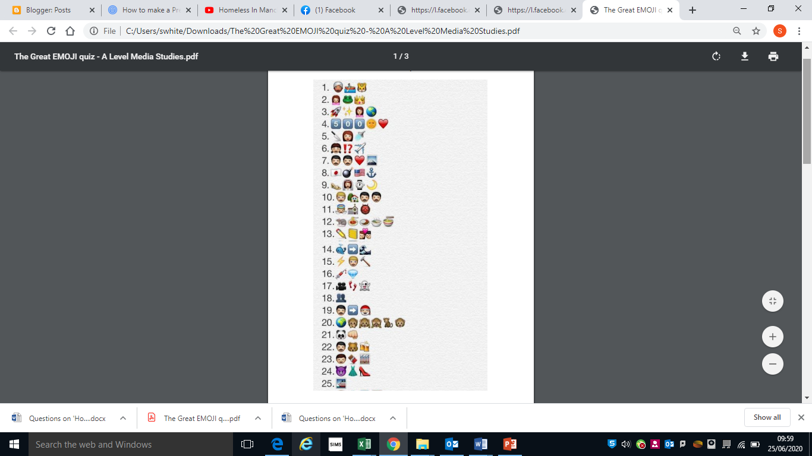
Look at the emoji sentences below and work out the film title. Put your answers in the box below.
1. 8.
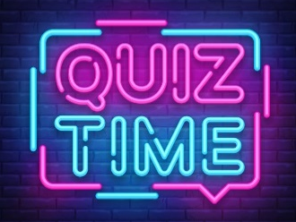
2. 9.
3. 10.
4. 11.
5. 12.
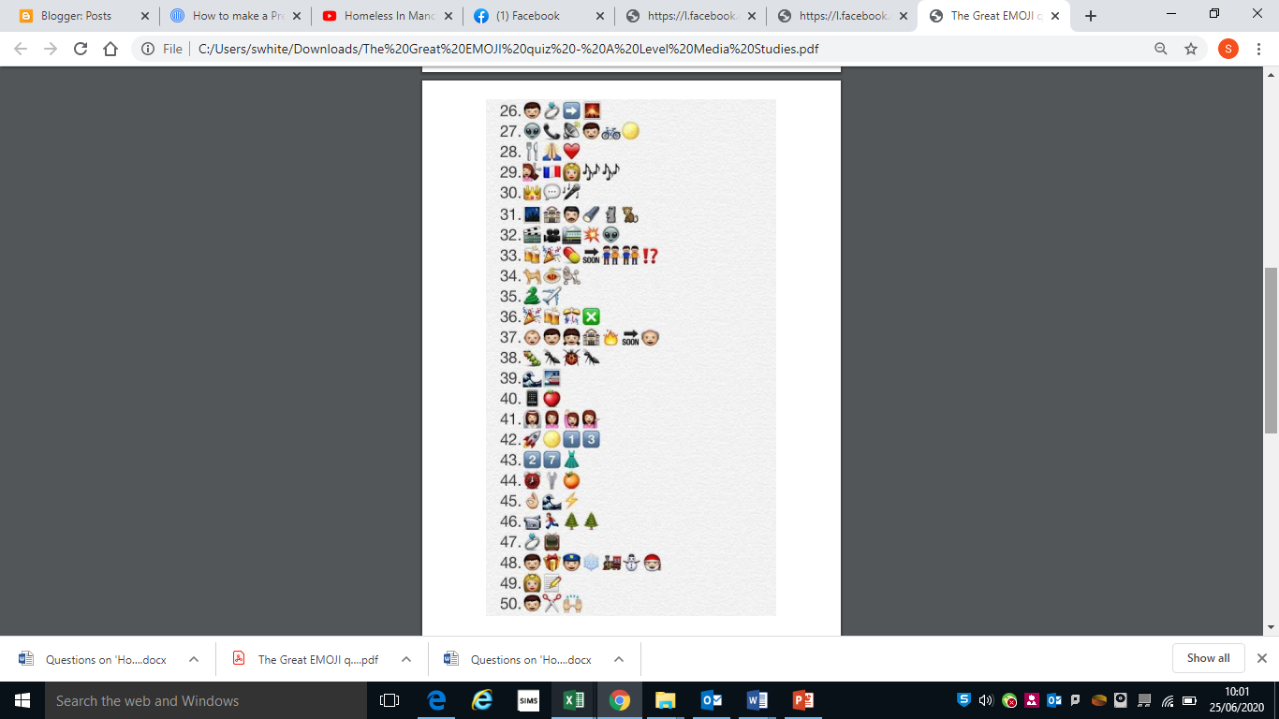
6. 13.
7. 14.
Answer box
1. | 8.
2. | 9.
3. | 10.
4. | 11.
5. | 12.
6. | 13.
7. | 14
Task Two: Film industry
Take a look at the posters for the films The BFG (2016) and Mandela: Long Walk to Freedom (2013).

Where do you normally see film posters?
1.
2.
3.
A distributor advertises a film, the distributor for The BFG is Entertainment One and the distributor for Mandela: Long Walk to Freedom is Pathe. You can find out more about what distributors do on the Film Distributors’ Association website www.launchingfilms.com

What do you think a distributor wants to achieve when they are deciding where to put their film posters?

Look at the posters above and draw lines to the list to analyse how the distributor has chosen to advertise the film.
- A tagline
- A picture that tells you about the genre
- Star power – an image of the lead actors.
- A quote from a film critic, newspaper/
magazine or website

- In cinemas date
- A quote from a member of the public
- A picture that tells you about the story
    - Star power – the names of the lead actors in large letters
What main differences can you see between the posters? Why do you think there are some differences?

What appeals to you most when you look at a film poster?

Task Three – Film Poster creation
During the induction lesson, you had to create your own film storyline idea (using 5 props from around your house) that would appeal to either 8-14 year olds or the 15-21 age bracket. Your narrative could’ve been within any film genre. You are now going to create the film poster for your film idea. However, before you create the poster we need to ensure we know what the poster format is like and its conventions (things we expect to see).

Key features or conventions of the film poster format.
These are the things you should be including on your poster and consider.

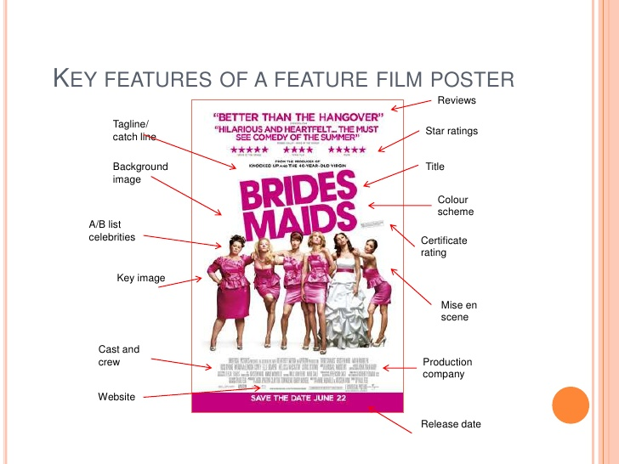

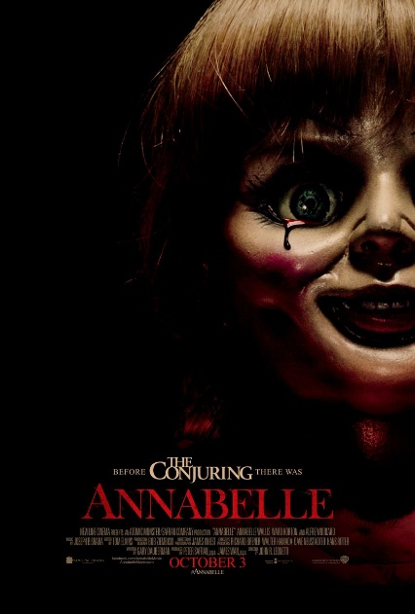
    - Watch the following clip from the professionals about how to design an effective film poster: https://youtu.be/Zhs2MEPCmjw

    - Now create your film poster using an editing program such as Paint.Net or Canva and send to Mrs White and Mr Lissaman
(swhite@clcc.college and dlissaman@clcc.college)

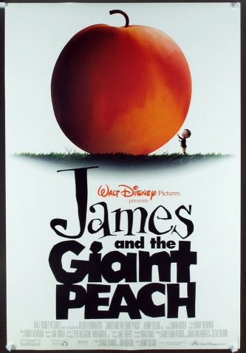
You could use one of the props that inspired your film idea as your main image.
E.g. a hat, pair of glasses, a doll, garden swing, a broken picture frame…
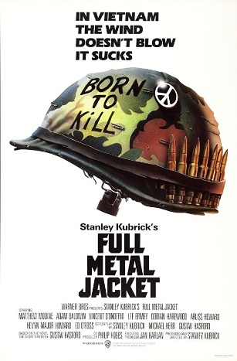
This can be very effective, see the examples below.
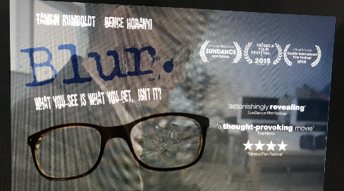

Below is an exemplar film poster template you can use if you wish.

Use existing film posters for ideas about how to layout your film poster as well as the info gained within the video you watched.

ONE IMAGE FROM THE FILM, AS A BACKGROUND FOR THE ENTIRE POSTER
LEAD ACTOR
LEAD ACTOR
LEAD ACTOR

FILM TITLE

Credits: the studio name, producer, scriptwriter, ‘lead actors, ‘film title’, music composer, costume design, editor, production design, cinematographer, executive producer, producer, story writer, screen writer and director... usually in that order.

.
DATE OF RELEASE

Task Four – Long Form Television Drama
As part of the Media Studies A level, you will be studying the way in which genre conventions are evident and used within your set texts.

Conventions are things that are typical or what an audience expect to see.
For example: Conventions of Rom Com films

A girl and the guy always get together in the end, there’s always a fight where they break up or one gets jealous, candlelight, romance, weddings, red and pink colouring, flowers, beach and city settings, actors such as Sandra Bullock.

- Using www.google.co.uk as a starting point and watching some clips or episodes complete a small-scale research activity to find out as much as you can about the conventions of long form TV Drama.
Ensure you look into:
- Type of narrative storylines – what do they usually include or are about?
- What characters and character types do you see? Are they male or female?
- How different media language elements have been used:
- camerawork
- sound – music, sound effects, dialogue tone.
- mise-en-scène – settings, props, colours, lighting, costume/ hair/ make-up, choice of actor.
- What sub genres or themes do you see within TV Long Form Drama?
- Examples of successful long form TV dramas.
- Why audience’s like Long Form TV Drama?
- How can audience’s watch TV Dramas – technology?
- Who are the key producers and distributors of long form drama?
You should watch at least one episode from two different Long Form TV Dramas. Some examples of long Form TV Drama are below but you can watch any others within the genre you prefer. Some ways you can access them are via BBC iplayer, 4OD, ITV player, Netflix, Amazon Prime, Now TV, Sky and the traditional DVD box set
Please ensure you are watching the appropriate certificate for each episode (15) as some vary between 15 and 18. We are not able to permit you to watch an 18 TV Drama episode if you’re under 18 years of age. Generally, the first episode within each series is a 15 if it’s an 18 overall.
Sons of Anarchy
Call the Midwife
The Crown
Mad Men
13 Reasons Why
Prison Break
The Americans
Breaking Bad
Band of Brothers
Taboo
24
The West Wing
The Good Wife
Arrow
Merlin
Little Fires Everywhere
Orange is the new black
Game of Thrones
Trapped
Sherlock
Downton Abbey
Vikings
The Marvellous Mrs Maisel
Big Little Lies
Mr Robot
Homeland
The Killing
Deutschland 83
Deutschland 86
Borgen
House of Cards
Stranger Things

TV Drama conventions

Name of TV Drama and episode viewed:
Type of narrative storylines – what do they usually include or are about? | What characters and character types do you see? Are they male or female? | Camerawork
sound – music, sound effects, dialogue tone. | mise-en-scène – settings, props, colours, lighting, costume/ hair/ make-up, choice of actor. | What sub genres or themes do you see within TV Long Form Drama?
Examples of successful long form TV dramas.  Who are the key producers and distributors of long form drama? | Why do audience’s like Long Form TV Drama? | How can audience’s watch TV Dramas – technology?
Name of TV Drama and episode viewed:
Type of narrative storylines – what do they usually include or are about? | What characters and character types do you see? Are they male or female? | Camerawork
sound – music, sound effects, dialogue tone. | mise-en-scène – settings, props, colours, lighting, costume/ hair/ make-up, choice of actor. | What sub genres or themes do you see within TV Long Form Drama?
Examples of successful long form TV dramas.  Who are the key producers and distributors of long form drama? | Why do audience’s like Long Form TV Drama? | How can audience’s watch TV Dramas – technology?
Notes page
………………………………………………………………………………………………………………………………………………………………………………………………………………………………
………………………………………………………………………………………………………………………………………………………………………………………………………………………………
………………………………………………………………………………………………………………………………………………………………………………………………………………………………
………………………………………………………………………………………………………………………………………………………………………………………………………………………………
………………………………………………………………………………………………………………………………………………………………………………………………………………………………
………………………………………………………………………………………………………………………………………………………………………………………………………………………………
………………………………………………………………………………………………………………………………………………………………………………………………………………………………
………………………………………………………………………………………………………………………………………………………………………………………………………………………………
………………………………………………………………………………………………………………………………………………………………………………………………………………………………
………………………………………………………………………………………………………………………………………………………………………………………………………………………………
………………………………………………………………………………………………………………………………………………………………………………………………………………………………
………………………………………………………………………………………………………………………………………………………………………………………………………………………………
………………………………………………………………………………………………………………………………………………………………………………………………………………………………
………………………………………………………………………………………………………………
………………………………………………………………………………………………………………………………………………………………………………………………………………………………
………………………………………………………………………………………………………………
………………………………………………………………………………………………………………

