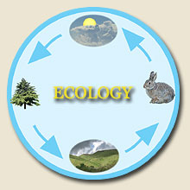

YEAR 10

SUMMER HOMEWORK

ECOLOGY IN ACTION

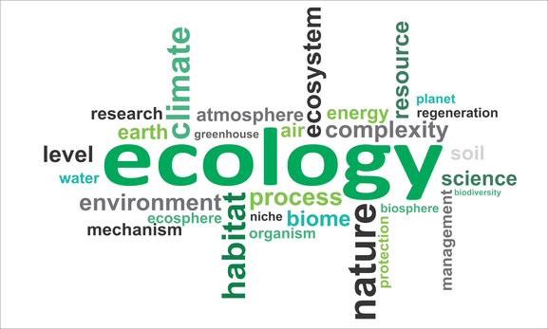

Name:

Date due:

Date set:

Desert Adaptations

1. Annotate the following images to show how the camel and the cactus are adapted to living in the desert.

2. How do these adaptations help them to survive in the extreme temperatures of the desert?

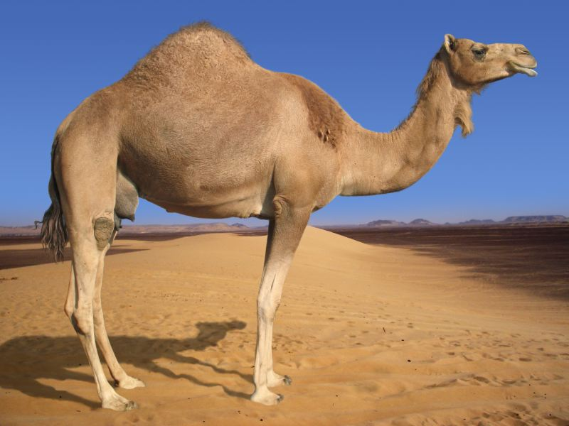

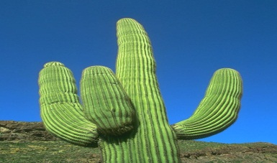

**Arctic Adaptations**

3. How is the polar bear adapted to the extreme cold temperatures? (Label the picture to show their adaptations)

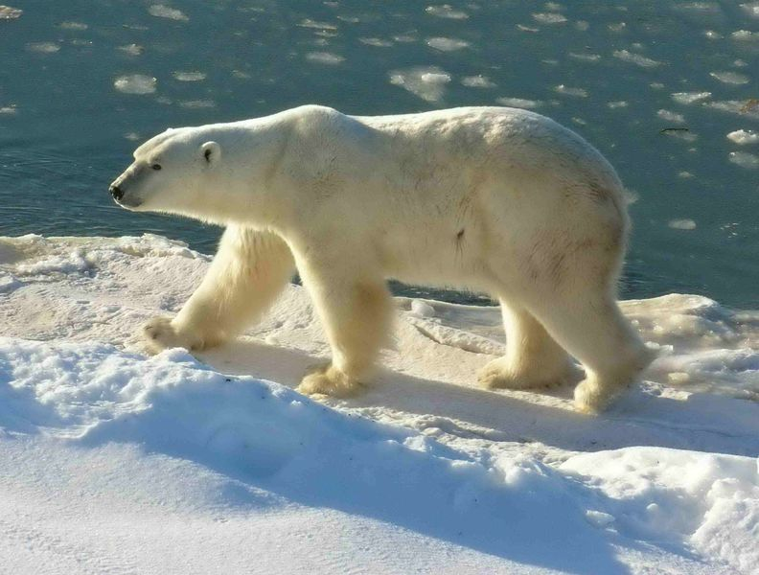

4.How do these adaptations help the polar bear to survive?

**Extension:** Explain what is meant by surface area to volume ratios and how they relate to survival in the desert.

**Adaptations to deter predators**

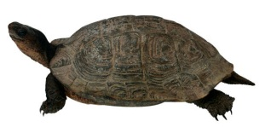C:\Users\sta.price01\AppData\Local\Microsoft\Windows\Temporary Internet Files\Content.IE5\0T8I01WD\MC900390696[1].wmf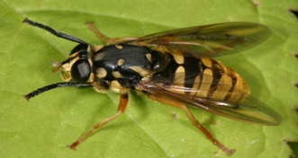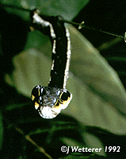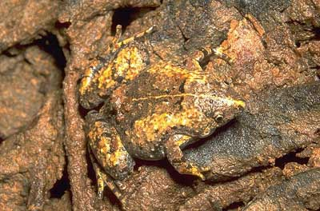5. Using the pictures below describe some ways which plants and animals are adapted to protect themselves from predators:

6. Some ecosystems have extreme conditions such as little available water (in the desert). Animals have to stop body temperature from getting too high or too low by changing their behaviour.

Suggest some **behavioural** adaptations of meercats

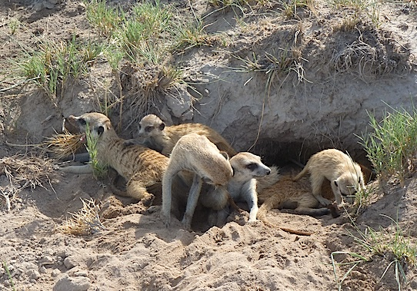

7. Research and then explain the difference between **structural** and **functional** adaptations, using **examples of animals** to illustrate your answer.

8. What are **extremophiles**? How are they adapted for survival?

**Extension:** Find out what **epiphytes** are and how they’re adapted to live in rainforests. Add a diagram to show what they look like

The Water Cycle Key words – match up the key words with their correct definitions

|  |  |  |
| --- | --- | --- |
| Key word | Diagram | Definition |
| Precipitation | MM900046572.GIF | When water vapour cools and turns into clouds |
| Condensation | MC900432588.PNG | Rain, hail, sleet and snow that falls from the clouds |
| Evaporation | MP900427753.JPG | When the sun heats up water from the leaves of trees. |
| Groundwater flow |  | When the water runs off the surface of the ground. |
| Surface run-off |  | When water flows through the rocks and soil underground. |
| Transpiration | MC900449051.JPG | When the sun heats up water from the sea and it goes into the air. |

The Water Cycle diagram

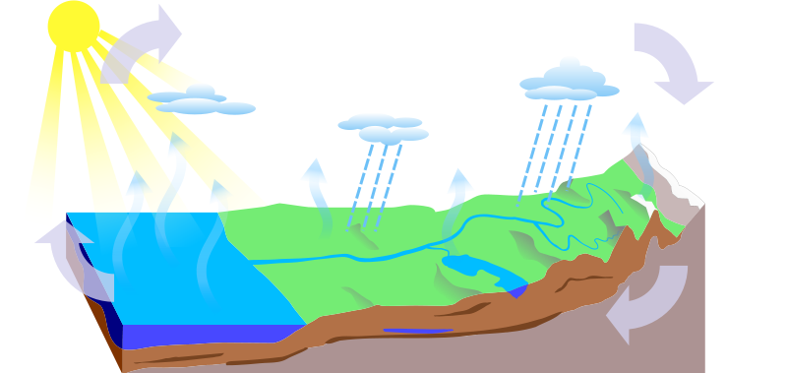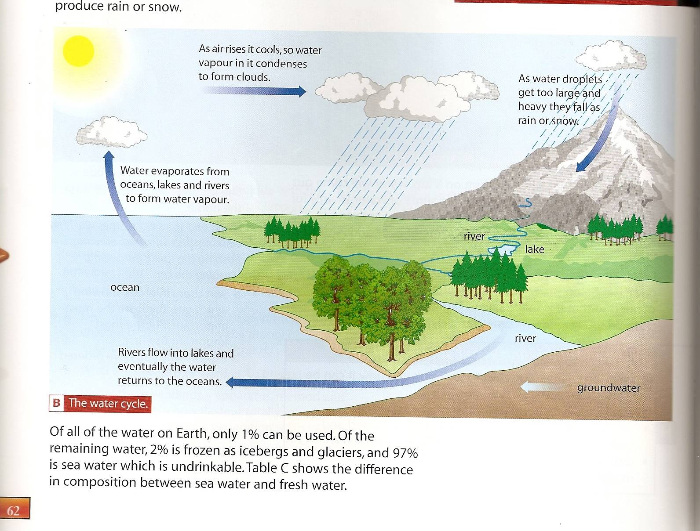

a) Add the key words to the diagram: condensation precipitation evaporation groundwater flow surface run off b) add in transpiration to the diagram

b) Draw on transpiration.

**Explain how the water moves from sea, air and land and back.**

Firstly the water starts off in the _________________ it then is transferred to the air by the process of ____________ this is when the sun heats the water and it turns into water vapour. The water vapour then cools and _______________ to form clouds, and falls as ______________. The precipitation then goes back to the sea either by_______________ or ___________________.

**The Carbon Cycle**

***Explaining the carbon cycle***

The atmosphere contains about 0.04% carbon dioxide, which is enough for every plant to produce biomass (food), by photosynthesis. This process transfers energy from the Sun into chemical energy.

When animals eat plants, they absorb carbon from them. Carbon passes along food chains, even when organisms die and decay. Energy is transferred along the food chain and to the environment at each trophic level.

Carbon dioxide is returned to the atmosphere by:

* Plants, animals and decomposers respiring:  
  glucose + oxygen → carbon dioxide + water
* burning (combustion) of fossil fuels and wood:  
  fossil fuel/wood + oxygen → carbon dioxide + water

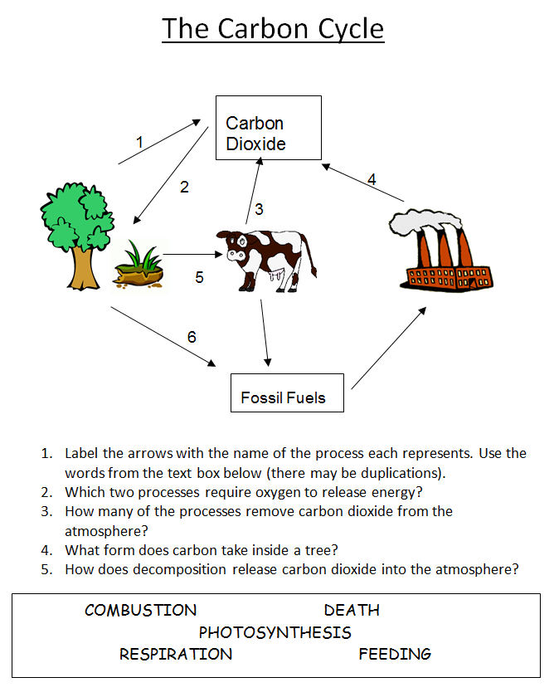The continual cycling of carbon is shown below:

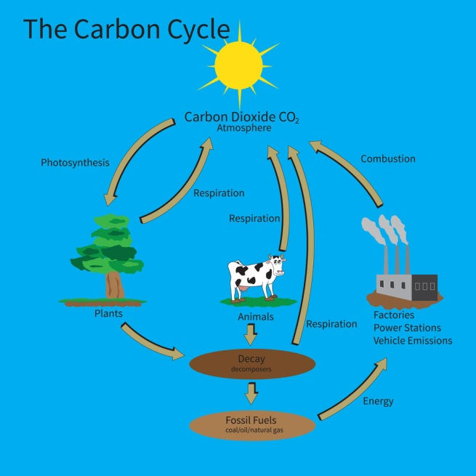

**The Decay Process**

Waste materials produced by living and dead organisms are recycled to provide nutrients and resources for future generations.

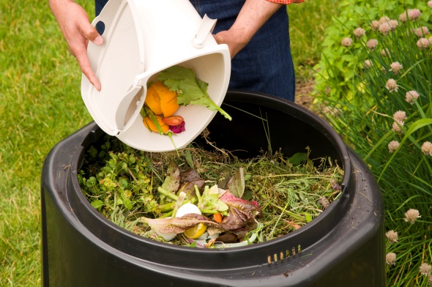

1. Find out how compost is made.

2. What conditions are needed to make compost quickly?

Learning about land use

The world's population has increased rapidly, from 1 billion (1000 million) in 1880 to about 7 billion in 2012. People use increasing amounts of the Earth's resources, resulting in a decrease in the land available for other organisms.

[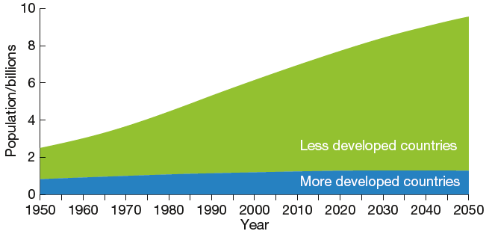](https://connect.collins.co.uk/repo1/Content/Live/JI/Leckie/AQA_GCSE_9-1_Biology_Student_Book_CPD83_New/Contents/assets/images/P352-1.png)

Humans are using more land for:

* farming

**TASK:** Research how each of these uses of land affects the plants and animals living there and write about each one in the table below.

* building
* quarrying
* dumping waste.

|  |  |
| --- | --- |
| Farming | Building |
| Quarrying | Dumping waste |

Changing the landscape

Huge areas of tropical forest are being destroyed. This **deforestation** is happening to:

* provide land for cattle and rice fields
* grow crops, for example, oil palm and sugar cane to make biofuels. Biofuel crops are sometimes grown at the expense of food crops.

Cleared forests are often used to grow a monoculture (one crop) over huge areas.

[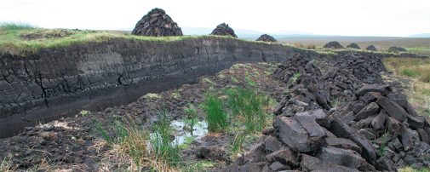](https://connect.collins.co.uk/repo1/Content/Live/JI/Leckie/AQA_GCSE_9-1_Biology_Student_Book_CPD83_New/Contents/assets/images/P354-1.png)Peat cut to be used for fuel

Forests are often destroyed by burning.

[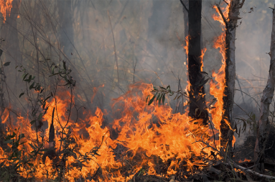](https://connect.collins.co.uk/repo1/Content/Live/JI/Leckie/AQA_GCSE_9-1_Biology_Student_Book_CPD83_New/Contents/assets/images/P355-1.png)

**Answer the following questions:**

**1.** Why are forests cut down?

2. What is peat and how is it used?

3. Describe and explain the impact of deforestation.

4. How can woodland habitats be preserved?

**Extension:** Evaluate the destruction of peatlands

**Pollution and biodiversity**

What is global warming?

**As our population keeps increasing, so our impact on the environment and biodiversity is also increasing.**

**TASK: Produce a colourful A3 poster or leaflet to answer the following questions:**

What is meant by biodiversity?

What waste substances do humans produce?

How do hedgerows increase biodiversity?

m

**Extension: Research in more detail your rare habitat and describe why it’s rare, where in the World is it found? What’s causing it to be destroyed, what is/can be done to try and conserve it. Add your findings to your poster/leaflet.**

What causes global warming?

Name a rare habitat & explain why it is important to protect it

How does global warming affect biodiversity?

What causes acid rain & how does it affect the environment?